AGRICULTURE FORM THREE

NEW SYLLABUS BASED NOTES
VOLUME 3

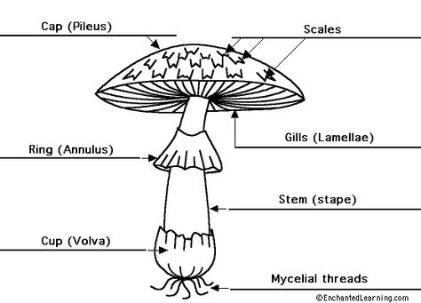

COMPILED BY

PHILLIP MLOWOKA GUDULU CHIRWA
(TARGET PRIVATE SECONDARY SCHOOL-MZUZU CITY)
Passing agriculture at MSCE has never been easy and straight forward. This pamphlet has brought all the resources which are requisite so as to lessen lavishness of precious time probing for valuable information in different books.

ACKNOWLEDGEMENT

My profound thanks should go my wife Chimwemwe Chakwira who indefatigably (tirelessly) encouraged working as if there is no tomorrow so that this pamphlet should be finalized despite the myriads of predicaments l encountered. I would be doing injustice if I do not recognize the omnipresent GOD for the free gift of life.

Special dedication to my daughter, MADALITSO CHIRWA

© PHILLIP CHIRWA 2022
All rights reserved. No part of this pamphlet may be reproduced, stored in retrieval system or transmitted in any form or by any means, electronic, mechanical, photocopying, recording or otherwise without the prior written permission.

Editor : Phillip Chirwa
Proofreader: Johnson chirwa
Designed by: Phillip Mlowoka Gudulu Chirwa
Date : 14th January 2022

TABLE OF CONTENTS
TABLE OF CONTENTS 3
UNIT 1: PHYSICAL PROPERTIES OF THE SOIL 4
UNIT 2: CHEMICAL PROPERTIES OF THE SOIL 17
UNIT 3: AGRICULTURAL DEVELOPMENT AGENCIES AND THEIR SERVICES 23
UNIT4 FARM RECORDS 29
UNIT 5 BUDGETING 34
UNIT 6 FARM BUSINESS DECISION MAKING 39
UNIT 7 ENTERPRISE COMBINATIONS 42
UNIT 8 AGRICULTURAL COOPERATIVES 43
UNIT 9 VEGETATIVE PLANTING MATERIALS 46
UNIT 10 CROPPING SYSTEM 51
UNIT 11 MUSHROOM PRODUCTIONS 56
UNIT 12 LIVESTOCK FEEDS AND FEEDING 66
UNIT 13 SHEEP AND GOAT PRODUCTION 73

UNIT 1: PHYSICAL PROPERTIES OF THE SOIL
- Soil has variety of physical properties which provides vital medium for plants growth.
- Physical properties of soil are;

- Texture
- Structure
- Colour
- Consistency
- Porosity
- Temperature
- Depth

- Soil Texture
- Refers to the proportion of sand, silt and clay in the soil
- Or the coarseness or finest of the soil particles
Textural classes of the soil
- Sandy soil: has more than 70% sand particles
- Clay soil: has over 40% clay particles
- Loam soil: has almost equal proportion of sand and clay
Comparing water holding capacity of the three textural classes of soil
- set up three measuring cylinders with funnels
- weight about 20g each of sandy, clay and loam soil
- put the samples in the funnels of the measuring cylinders and label them A, B,C
- pour 50ml of water into each of the funnels
- observe the water as it drains and stops coming through
- record the time when the first drop of water comes through the funnels
- After ten to fifteen minutes measure and record the amount of water that has drained through each of the soil samples.
- calculate amount of water held by each soil sample by subtracting the amount the amount of water drained from the 50ml of water that poured into each funnel
Particle sizes of clay soil
Particle | Sizes(mm) diameter
Clay | Below 0.002
Silt | Between 0.02 and 0.002mm
Fine sand | Below 0.2 and 0.02mm
Coarse sand | Between 2.0 and 0.2
Gravel | Above 2.0mm
Summary of characteristics of three textural classes of soil
characteristics | Sandy | clay | Loam
Particle sizes | Large | small | Medium
Drainage | Very high | Very low | Moderate
Water holding capacity | Very low | Very high | Moderate
Aeration | Very high | Very low | Moderate
Nutrient holding capacity | Very low | Very high | Very high
Cultivation | Very easy | difficult | Easy
Root penetration | Very easy | difficult | Easy

How is the soil analysed
- Scientist collects soil samples of about 15-20g, which they grind finery.
- they separate gravel and sand particles from silt and clay through sieving-they stack four sieves of different mesh sizes to separate the soil particles
- they weight the amounts of gravel and sand separately and express the mass as a percentage
- Silt and clay are separated through sedimentation in water and weighed.
- they express them mass of sand , silt and clay as weight percentage using the amount of dry soil as basis
- once they these percentages they use soil triangle to classify soil texture
Soil texture triangle
- Is used to classify the textural class of the soil.
How to use soil triangle
It has three axes, namely clay, silt and sand
- The total percentages should add up 100%
Example locate soil sample R which has 45% sand, 40% silt and 15% clay
- Locate 45% of sand on sand axis and draw line parallel to its axis
- Locate 40% on silt axis and draw a line parallel to clay axis
- Finally locate 15% clay axis and draw a line along its axis
- The three lines have intersected at one point in the triangle. The points where three line meet give the name of texture. In our example here its loam soil
- Note that the total percentage in soil sample should add up to 100%
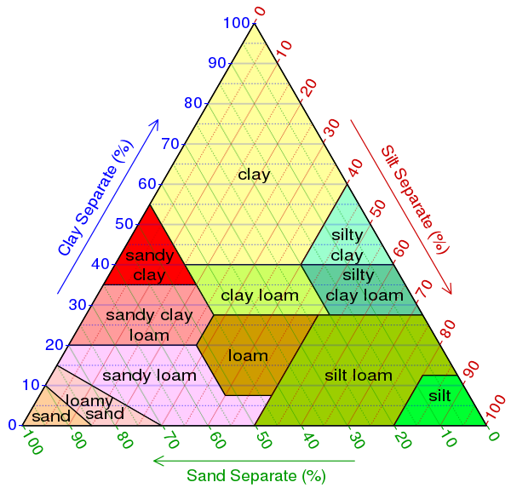
WAYS OF DETERMINING SOIL TEXTURE
- sieve or sifting method
Material required
- soil sample
- Sieves of different sized mesh i.e. 2mm, 0.2mm, 0.02mm, and 0.002mm in diameter.
Procedure
- Weigh the collected sample and record its mass
- break the soil sample into small particles
- take a sieve of 2mm mesh
- Sieves the soil through the 2mm mesh. Soil particles greater than 2 mm in diameter will not pass through.
- Repeat the exercise with sieves of 0.2mm, 0.02mm, and 0.002mm.
- Weigh the samples in different sieves
- Calculate the percentage of each collected sample using the total weight.
- Feel method
- Collect different lamps of soil
- Add a little water to the soil
- Take the soil between the thumb and the fore finger
- Feel the soil as you move the two fingers
- Try to mould the soil
- Sandy soils feels gritty and coarse while clay soils particles feel fine and sticky when wet. Clay can also be moulded into balls or sausages
- Sedimentation method
Materials
- Garden soil
- Water
- Sodium carbonate
- Measuring cylinder
Procedure
- Collect a dry lamp of soil
- Put soil sample into a transparent container or cylinder
- Add 5g of sodium carbonate powder to break soil particles further.
- Add water until the cylinder is 75% full
- Cover the mouth of the cylinder and shake vigorously
- Leave the cylinder to allow the contents to settle down
- Determine the percentage of each particle found in the soil using the volume of each observed layer.
Expected results
- Soil settles according to their mass. The heaviest will settle first followed by the second heaviest and so on.
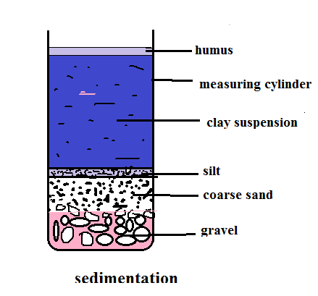
Effects of soil texture on crop production
- it influences soil aeration: sandy soil allow air to circulate easily for root respirations and plant growth
- It influences water holding capacity. Clay soil holds more water than sandy soil for plants growth.
- It influences nutrients holding capacity. nutrients a leach more easily in a coarse-textured soil than in fine-textured soil, but are more held more firmly for crop production in fine textured soil
- It influences soil drainage: coarse textured soil is better drained for crop production than fine textured soils.
- It influences tillage: coarse textured soils are easier to till than which is fine-textured.
- It influences resistance to erosion; sandy soil is easily eroded.
- It influences the type of crop to grow.
- Root development and extension: A soil which is too hard and compacted prevents roots from extending to search for water and mineral salts from wide volume of soil.
- SOIL STRUCTURE
- Refers to the arrangement of soil particles to form aggregates/collections
- These particles are: clay. Sand and silt.
- For aggregation to be possible cementing agents are needed and theses are
- Clay
- Organic matter (humus)
Types of soil structure
- Naming of soil structure is determined by two factors
- Shape of soil particles
- Arrangement of soil particles
- There are eight type and these are
- Platy structure
- Particles are horizontally arranged on a plane. They are flat and plate-like. Soils with such structure have low permeability.
- Blocky structures
- Particles are joined to form six-sided rectangular lumps (blocks).
- Cuboidal structure
- Soil particle are joined to form cubes or cube-like shapes
- Columnar structure
- Particles are arranged in column with round tops and cylindrical body
- Prismatic structure: Particles join to form vertical pillars with flat tops.
- Granular structure: particles are loosely packed, forming aggregates that are round or ovoid
- Crumb structure: particles are loosely joined to form friable, porous aggregates with irregular shapes. This is the soil best soil structures for arable crop production as it ensure a suitable balance between soil aeration and water holding capacity.
- Single grained structure: Particles are not cemented together. each particle is on its own(e.g. sandy soil)
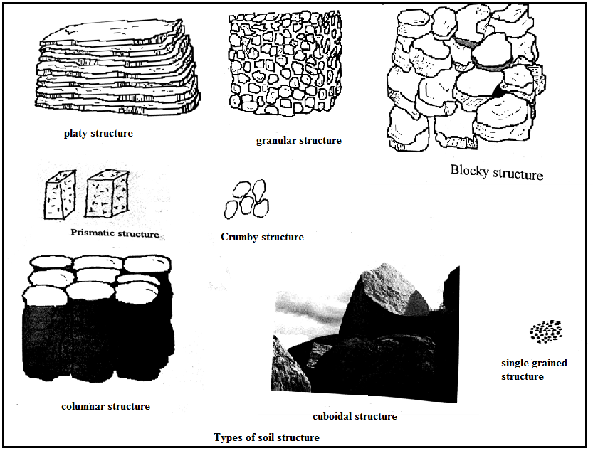
Effects of soil structure on crop production
- Air circulation in the soil: single grained structures soils allow better movement of soil air for plant root respire than platy soils.
- Water holding capacity of the soil; crumb soils hold water for plants to use while single-grain and granular structures lose water more readily through seepage.
- microbial activities in the soil; crumb structures have a better environment for micro-organism to live and work more actively to break down organic matter to release nutrients for plants growth than single grain structures
- soil workability; granular structures are more workable than platy structures
- nutrient retention: crumb structures reduce the rate of leaching of mineral sails while single grain structures lose nutrients through leaching more easily
- root penetration and development: platy structures hinder root development while single grain structures facilitates root development
Ways in which soil structure can be destroyed
- Cultivating it when too wet or too dry. When it is too dry, it tends to breaks so easily. Wet soil gets compacted during cultivation.
- Over-cultivating, which leads to failure of soil to recover after being broken.
- Using heavy machinery which compacts the soil even breaks down the soil structure.
- Raindrops impact: break the soil particles break up and fill up soil pores making it more difficult for water and air to enter the soil than before.
- Overgrazing which leads leaves bare land making it prone to raindrop impacts which breaks the soil structure.
- Applying unsuitable chemical fertilisers. For example, application of sodium compounds to the soil causes deflocculating (breaking down) of soil structure.
Soil structure can be improved and maintained by the following operations
- Planting vegetation on bear land which protects it against raindrop impact
- Correct crop population ensures complete coverage of land against rain drop impact.
- Use of organic fertilizer (manure) help to bind the sol particles together and also ensures stability of aggregates.
- Crop rotation prevents soil from being broken down by the force of raindrops this is achieved by including cover crops.
- Fallowing: leaving land crop-free for some years enables it to regain its organic matter which cements soil particles together to from aggregates.
- Zero grazing: enables soil to regain its organic matter which cements soil particles together to from aggregates.
- Proper use of heavy agricultural machinery by combining operations like ploughing, harrowing and ridge construction thereby reducing soil compaction.
- Avoiding overgrazing so that soil is not compacted significantly and soil does not lose vegetative cover.
- Mulching prevents the soil aggregation from being broken by force of rain drops.
- SOIL COLOUR
- It refers to the appearance of the soil
Factors that affect soil colour
- Parent material: reddish or brown soils indicate that contain iron, silica or quartz (limestone) are whitish in colour and mica has glittering(shiny) appearance
- Organic matter: soils containing large quantities of organic matter are usually dark/black in colour
- Drainage and aeration: poorly drained and aerated soils are usually greyish as opposed to well drained soils which are brownish in colour.
Determination of soil colour
Materials: soil samples, soil colour chart
Procedure:
- Collect soil samples
- Compare its colour with that shown on the chart
- Record the findings
Expected results
- yellow and grey indicates that the soil is poorly drained and suffers from prolonged water logging
- brown to black indicates that the soil is well drained with some degree of organic matter
Effects of soil colour on crop production
- It keeps soils temperature warm like black colour
- It influences the rate at which mineral salts dissolve in soil water and become available for plants use.
- It also influences the rate at enzymes in seeds can break down food reserved necessary for seed germination.
- It influences the activities of micro-organisms which decompose organic matter
Dark soil absorbs more heat as compared to whitish soils which reflects most of its heat as a result agricultural soils must be dark.
- Soil consistency
- The state of soil under different moisture conditions
- Soil consistency determines the easiness with which the individual particles can be crushed by fingers or cultivation tools
- Soil can be described as soft, friable, plastic, firm depending on the difference in consistency.

Factors that affect soil consistency

- Moisture content
- Soil structure
Determination of soil consistency using hands:
- Moist soils
Procedure
- Collect soil samples
- Moisten the slightly
- Press a small amount of soil between forefinger and thumb
- Rate each soil sample as being loose, friable or firm
- Record your findings
Expected results
Loose soil (sandy) | Friable (loam) | Firm soil (clay)
Do not hold together | Are crushed easily under gentle pressure | Can be crushed under moderate pressure

- Wet soils
- Consistency will determined by stickiness of the soil
Procedure
- Collect samples of soil
- Wet the soils
- Press a small amount of soil between the finger and thumb
- Open the fingers slowly
- Observe
- Rate the soil as non-sticky, slightly sticky, sticky or very sticky
Expected results
- Soil can be non-sticky(sandy), slightly sticky(loam soil), sticky or very sticky(clay).
Consistency can also be determined by plasticity of the soil(the extent to which soil can be rolled into a ribbon)
Procedure
- Collects samples of soil
- Wet the soils
- Roll the soil sample between the fingers and the thumb to form a ribbon
- Observe
- Rate the soil, as non-plastic, slightly plastic, plastic or very plastic
Expected results
Non-plastic (sand) | Plastic (loam) | Very plastic (clay)
No ribbon formed when the soil is rolled | A ribbon is formed and can be broken easily. The soil can return to its original state | A ribbon is formed and cannot be broken easily. The soil can be rolled back to its original position
b. Dry soil
Procedure
- Collect different soil samples
- Dry the soil for two days
- Try to break the soil samples between the thumb and fingers
- Observe
- Rate the soil as loose, hard or very hard
Soft (loam and sand) | Hard (clay)
Can break easily under slight pressure | Not to be crushed
Determination of the soil consistency using cultivation method
Materials
- Hoes, 10 litres of water
Procedure
- Pour 7.5 litres of water on one part of the soil and 2.5 litres of water on the other part
- Cultivate the soils; with hoes
Expected results
- The soil with 2.5 litres of water is easier to work with
Conclusion: soil consistency change with the amount of water present in the soil
Effects of soil consistency on crop production
- Workability; sticky soils are very difficult for farmer to work with because the soil sticks to farming implements like
- hoe, ploughs, ridger etc
- Destruction of soil structure. Plastic/sticky soils get compacted and reduce their porosity. This in turn reduces air circulation, water infiltration and percolation and plants roots penetration through the soil
- Erosion. Soils that are weakly cemented easily break into individuals’ soil grains and become more subjects to erosion.
- Seedling emergence. Plastic soils break easily by heavy rainfall. This makes it difficult for emerging seedlings to get out of the soil.
- Soil porosity
- Percentage volume of the total bulk of the soil which is not occupied by soil particles.
- Or proportion of volume of soil that is taken up by pore spaces
- Clay has the highest porosity because it has tiny pores spaces which are many
- Sandy soils has lowest porosity because it has few pore spaces which are large in size
Percentages of porosity
- Depends on soil texture. It ranges from 40% in sandy soils to about 60% in clay and loam soil is about 55%
Calculation of porosity
- Best described by bulk density and particle density
- Bulk density: mass of oven dry divided by volume of oven dry soil. includes both pores spaces and solid particles
- Particle density: is defined as the mass of unit volume of solid.
$$bulk density=\frac{weight of oven dry soil}{volume of oven dry soil}$$
$$particle density=\frac{weight of solid soil}{volume of the soil solid}$$
$$\%porosity=100-\frac{bulk density}{ particle density}×100\%$$
EXAMPLE: if ${10cm}^{3}$ of soil weighs 50grams.calculate bulk density porosity if the soil was compressed to occupy 80% of the cubic.
$$bulk density=\frac{50g}{10{cm}^{3}}=5g/{cm}^{3}$$
$$particle density=\frac{50g}{8{cm}^{3}}=6.25g/{cm}^{3}$$

$$\%porosity=100-\frac{5g×{cm}^{3}}{{cm}^{3}× 6.25}×100\%$$
$$=100-80$$
$$=20\%$$
$$note that by compressing the soil, the volume decreases while mass$$
$$remains constant$$
Determination of porosity
Experiment 1
Materials required: a lump of soil, measuring cylinder, beam balance, burner, matches, and crucible
Procedure
- Heat the soil gently in a crucible until the water evaporates from the soil
- weigh the soil
- Heat the soil again until the weight is constant
- Find the volume of the heated soil
- Calculate bulk density using this formula=$\frac{weight of oven dry soil}{volume of oven dry soil}$
- Compress the soil again
- Record the volume
- Calculate particle density as weight as weight of solids divided by the volume of the solids
- Calculate percentage porosity using this formula=$100-\frac{bulk density}{ particle density}×100\%$
- Note that porosity can also be determined by determining water holding capacity of the and capillarity of the soil in experiment
Experiment 2: To determine the capillarity of different soil
Materials: three long capillary tubes, cotton, water trough, clock, a ruler, dry sand, dry clay soil, dry loam soil
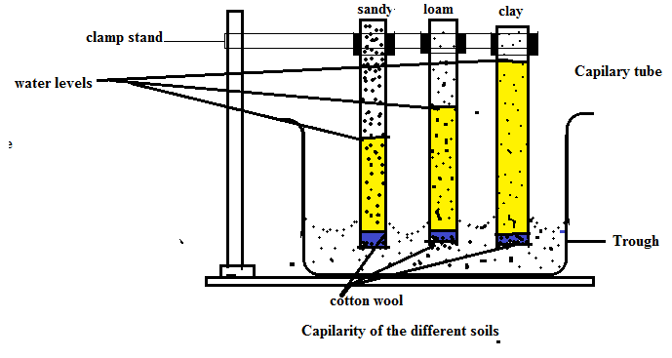Procedure:
- Crush all soil except sand
- Close one end of the each tube with a plug of cotton wool
- Fill each capillary tube with different soil type
- Support each tube with a clamp stand in an empty water trough.
- Pour water into the water trough to a depth of 10cm
- Removes the tubes from the trough after 5 minutes and measure the height of water in every tube
- Then leave the apparatus overnight and measure
Observation
- Water rises in sandy and loamy soil but very slowly in clsy soil in the forst 5 minutes
- After 24 hours the water level in clay is the highest followed by loam soil and final sandy soil
Conclusion
- Clay soil has the highest capillarity because of fine pore spaces
- Loamy soil has organic matter which absorbs water relatively fast
- Sandy soil has poorest capillarity because of its large air spaces.
Porosity affects crops in the following ways
- Aeration: soil which is porous allows air to circulate easily for seed germination and respiration of microbes and plants roots.
- Water infiltration and percolation: water infiltration rate is fast in porous soils for dissolution and uptake of nutrients.
- Nutrient retention: porous soils are poor in retaining nutrients because most of them are drained to deeper soil horizons where most plants roots cannot reach.
- Root penetration and development. Micropores impede root penetration thereby reducing yield in crops like cassava and potatoes greatly.
- SOIL TEMPERATURE
- Refers to the coldness or hotness of the soil.
- How is the soil temperature determined
- Soil temperature is used to determined soil temperature.
- Push the thermometer into the soil and wait to see consistent readings for few days.
Factors that affects soil temperature
- Soil colour: dark soils have higher soil temperature because they absorb more heat.
- Vegetative cover: covered soil receives less heat from the sun hence low temperature.
- Soil moisture content: a moist soil is generally cooler than dry soil
- Latitudes: soils that are close to the equator are hotter than those soils close to the poles and this is because the sun is overhead more times than any other place on earth.
- Season of the year: the soil that is exposed to sunlight, longer in summer than in winter.
- Slope of the land: a garden which slopes towards the north in the southern hemisphere is heated more than land which faces south.
- Soil depth: topsoil experiences more temperature variation or fluctuations than sub soil.
Determination of soil temperature
Materials: different soil samples, container, thermometers.
Procedure:
- Collect the soil samples from outside environment by using the containers
- Push the thermometer into soil sample
- Wait for few minutes
- Record the readings
Effects of soil temperature on crop production
- High soil temperature increases chemical reactions in the soil hence more mineral salts dissolve into soluble minerals which become more available
- High soil temperature increases activities of the microorganisms in the soil e.g. nitrifying bacteria becomes active when soil temperature is high
- Seed germination and root growth is fast when soil temperature is high
- Absorption and transport of water and nutrients by plants is low when temperature is low.
- Rate of evaporation and transpiration is high when soil temperature is high.
Ways of modifying soil temperature
- Manure application: manure absorbs more heat from the sun since it is black hence high soil temperature.
- mulching crops(spreading leaves, dry grass or other vegetative matter on the soil)
- Planting vegetative cover since it allows soil to heat slowly during the day and cools down slowly during the night.
- Irrigating and draining the soil to reduce the temperature.
- Growing crops in green house since the temperate is controlled
- Draining the soil help to warm up the soil hence increasing its temperature
- SOIL DEPTH
- soil depth is the combined depth of the soil and sub soils
- Examples of deep rooted crops: cotton, tea, coffee need deep soils in order to do well
- Soils which are well developed and mature tend to be deep. Deep soils have a very deep top soil layer. They also have a well-developed sub soil layer. on the other hand, shallow soils have
Factors that affect soil depth
- Slope of the land: soils on steep slope are shallow because of erosion while on flat and low lands are deeper because there is no relatively erosion and some soils are deposited there from highlands.
- Parent material: parent material which are resistant to weathering form deep soils.
- Age of the soil: young soils are shallow since there is little volume of soil formed
Determination of soil depth
Materials: tape measure or ruler, a hole, land
Procedure:
- Dig a pit
- Measure the depth of each horizon using a ruler or a tape measure
- Record the measurements
Effects of soil depth on crop production
- Amount of nutrients: the deeper the soil the larger the volume of soil from which plants can absorb nutrients hence high crop production.
- Amount of soil water: the deeper the soil, the more water it can hold, making it possible for crops to survive longer periods of dry spell
- Root development: deeper soils promote root development because of large volume of soil hence shallow soils can only accommodate shallow rooted crops.
- Control of soil erosion: deep soils helps in controlling soil erosion since they hold large amount rain water.
- Microbial activities: the deeper the soils the greater the zone available for soil microorganism to break down organic matter.
- It determines the choice of that can be grown on particular land. Soils that are deep and loose are favourable for most plants because their roots can go as deep as they want without restriction. On other hand shallow soils can only accommodate shallow rooted crops.
- Soil aeration: the deeper the soil, the greater the aeration in the soil for root respiration and development for increased crop production.
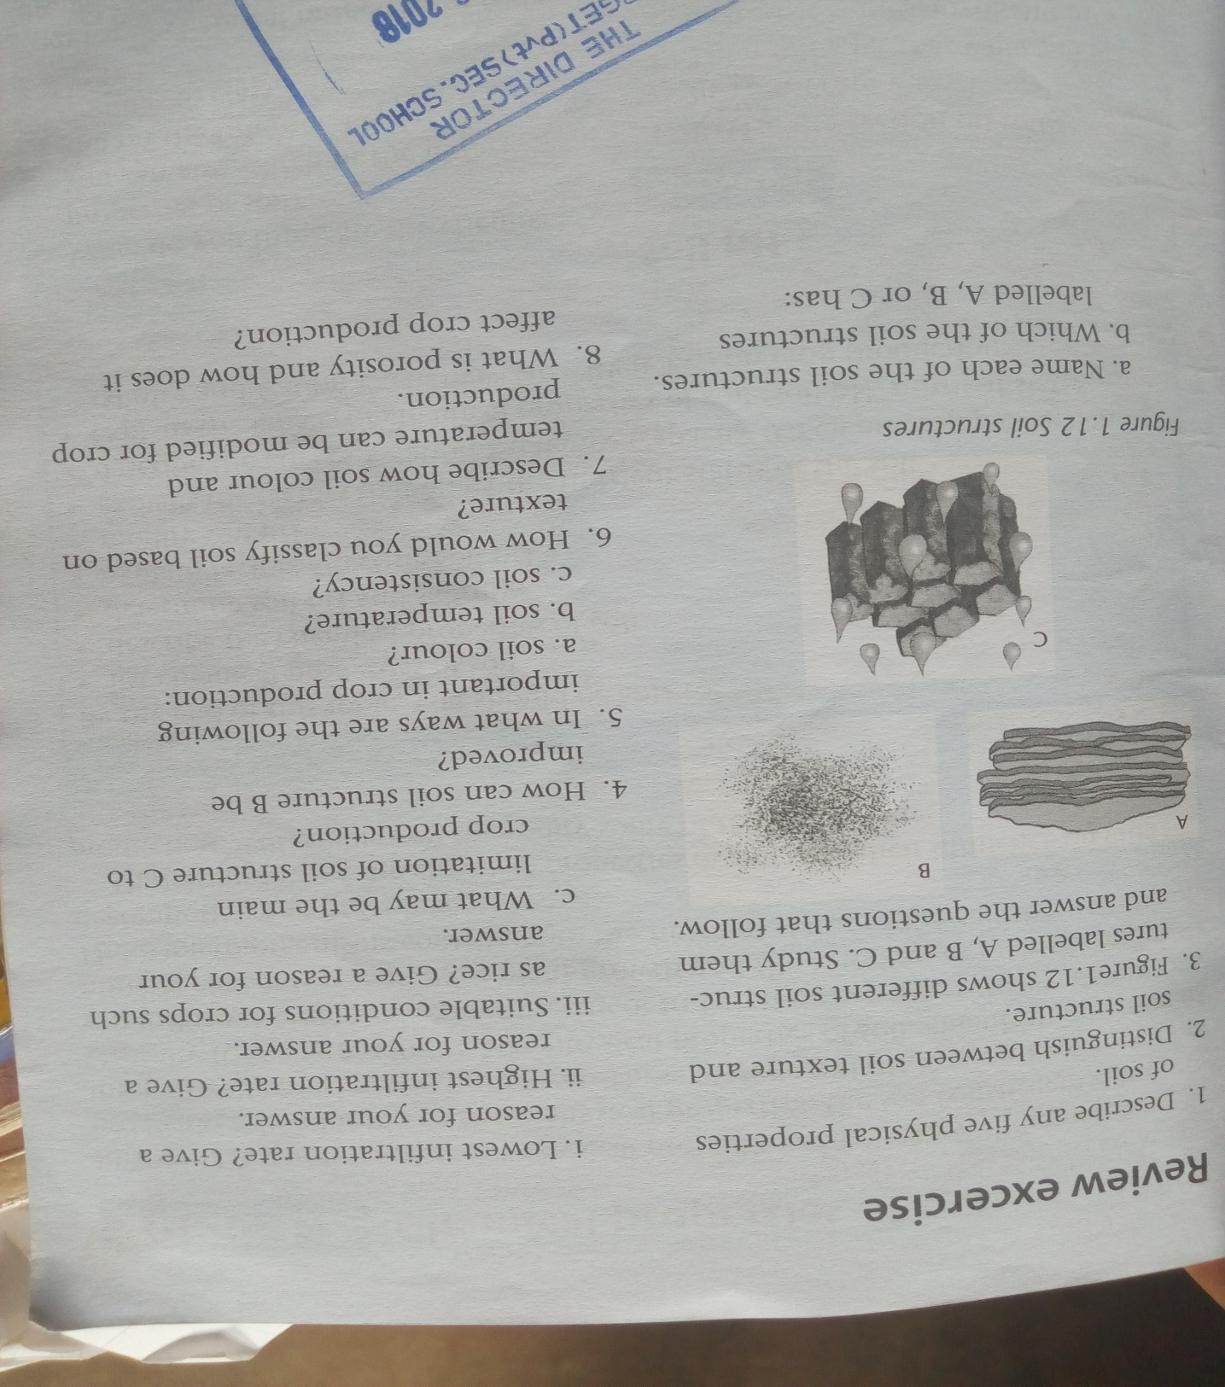

UNIT 2: CHEMICAL PROPERTIES OF THE SOIL
- They affects availability of essential mineral elements in the soil and activities of micro organism
List of chemical properties of the soil
- PH
- Nutrient status
- Salinity
- Cation exchange capacity
- Soil PH
- Refers to the degree of acidity and alkalinity of a soil.
- This is a result of concentration of hydrogen ions ($H^{+}$)and hydroxyl ion (${OH}^{-}$)in the soil
Ways determining soil PH
- Use of universal indicator
Materials required
- Dry soil sample
- universal indicator
- PH scale
- Distilled water
- Test tube
- Cork
- Barium sulphate
Procedure
- take a small sample and grind it
- put it in a test tube
- add a chemical like barium sulphate to break the soil particles further
- add distilled water in a test tube followed by few drops of universal indicator
- cover the top with a cork
- shake the test tube vigorously
- let the mixture settle for not less than 30 minutes
- observe the colour change in the test tube
- compare the colour change in the test tube with the colour on the colour chart and read off the PH
Expected results
- if the soil is acidic the indicator changes to red
- if the soil is an alkaline it changes to blue
- if soil is neutral it changes to green
- PH less than 7 indicates the soil acidic
- PH greater than 7 indicates a basic/alkaline soil
- PH 7 indicates a neutral soil

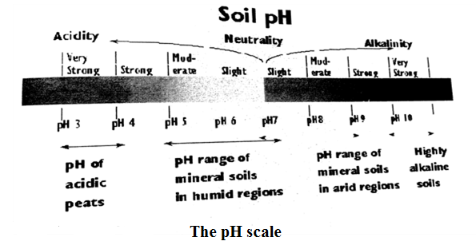
- Determining soil PH using litmus paper
Materials
- Soil sample
- Distilled water
- Test tube
- Litmus paper( both blue and red)
- PH scale
Procedure
- Put a well grinded soil into a test tube
- Add distilled water
- Add barium sulphate to break soil particles to individual grains
- Let the mixture settle down
- Dip litmus paper
- See the colour change on the litmus paper
Expected results/outcome
- Red litmus paper turn blue if soil is basic and
- Blue litmus paper turn red if the soil is acidic
c. to determine soil pH using a pH meter.
Materials: pH meter, soil sample, distilled water
Procedure:
- Put a well grinded soil into a test tube
- Add distilled water
- Add barium sulphate to break soil particles to individual grains
- Let the mixture settle down
- Dip an electrode of a pH meter into the soil solution
- Record the reading on the screen
Expected results: pH values less than 7 means that the soil; is acidic and pH values greater than 7 means the soil is alkaline.
Factors affecting soil PH
- Use of acid forming fertilizers: the continuous and heavy application of sulphate of ammonia makes the soil acidic.
- Leaching:
- When plant nutrients such as calcium (${Ca}^{2+}$), magnesium ${(Mg}^{2+})$ and sodium$({Na}^{+}$) are leached down the soil profile, they are replaced by hydrogen ions which lowers soil PH.
- Microbial activity:
- Reduces soil PH as hydrogen ions are released during decomposition of organic matter making the soil acidic.
- Carbon dioxide produced by microbes dissolve in water to form carbonic acid decreasing soil pH (making soil acidic)
- Acid rains
- Carbon compounds emitted into the atmosphere in industries when combines with water to from carbonic acid which gets incorporated into the soil making it acidic.
- Crop removal:
- Crops absorb various ions in soil and after harvesting if the crops are not incorporated in the soil this will leave hydrogen ions to dominate the soil (making the soil acidic).
- Weathering of parent material:
- if it contains sulphur, PH is reduced through formation of sulphuric acid, making soil acidic
- soils from limestone have a high PH , making them alkaline
- it also results in accumulation of ions like $k^{+}$,${Na}^{+} and {Mg}^{2+}$ which increase soil PH, making it alkaline
- Drainage:
- It is linked to leaching and sandy soil since it highly leached tend to have low PH than clay soil which has high soil PH due to low levels of leaching.
- Type of vegetation: in forest soil PH tends to be low as compared to grassland this attributed by high levels of soil decomposition of organic matter.
WAYS OF MODIFYING SOIL PH
- Application of agricultural lime which contains calcium oxide. Agricultural lime when applied to the soil neutralises soil acidity.
- Application of manure e.g. khola manure reduces soil acidity.
- Application of inorganic fertilizer like sulphate of ammonia decreases soil pH. i.e makes soil acidic
Effects of soil PH on crop production
- Affects availability of soil nutrients: e.g. at low PH become insoluble by forming less soluble compound like iron and aluminium while iron and potassium become available in the soil at high soil PH and plants can access them.
- It determines the choice of crop to be grown in an area. Acid soils are best for tea production.
- High acid soils limit the activities of microorganism and this means organic matter incorporated into the soil will not decompose and nutrients will not be released for plant growth
- In acid soils, damage of crops by nematodes is more serious than in neutral soils

- NUTRIENT STATUS OF THE SOIL
- This has to do with availability of different minerals in a soil in right proportions. It is these nutrients which determine a soil’s capacity to support crops
Factors affecting nutrient status of the soil
- The parent material from which soil was formed. Soils formed from limestone tend to have high contents of calcium. While soils formed from sandstone and granites give rise to sand soil which is low in nutrient contents.
- Soil PH.
- Affects availability of nutrients in the soil for instance phosphorus in acidic soils become insoluble and therefore unavailable to plants.
- It also influences multiplication and activities of beneficial soil organisms some of which are responsible for nitrogen fixation and decomposition of organic matter.
- Leaching: in sandy soils, during heavy rainfall soluble salts like nitrates are washed down the soil profile, leaving the top soil with low nutrient status.
- Nutrients uptake by plants: nutrients extracted by crops if not ploughed back into the soil, more nutrients are lost.
- Crop removal: nutrients are removed with crops as they are being harvested.
- Soil erosion: when top soil is eroded, it goes away with mineral nutrients it contains.
- Method of cultivation: use of bush fire to clear land, overgrazing, monocropping, improper use of farm machinery, cultivation of marginal land affects the availability and removal of plants nutrients.
Effects of nutrient status on crop production
- It affects vegetative growth of crops: nitrogen for example is responsible for synthesis of protein molecule which is necessary for growth,
- Some nutrients like phosphorous: brings forth resistance against diseases due to lignin they form.
- They affect maturity of crop. Tobacco matures if amount of phosphorous supersedes that of nitrogen. Nitrogen promotes succulence while phosphorus brings maturity.
- Yield potential of crops and is imperative for farmer to maintain high nutrient status of the soil by applying fertilizers.
- Soil PH. Determines choice and productivity of crops

- SALINITY
- Is a condition of the soil that is associated with the accumulation of soluble salts in the soil
- Saline soil: soils which contain concentration of neutral soluble salts with a PH of more than 8.5.
- Saline soils are sometimes called white alkaline soils this is when a white layer on top of soil becomes very visible.
Examples of soluble salts

- Nitrates
- Sulphates
- Chloride
- Bicarbonate

- Sodic soils: soils which contain high amount of sodium
- Soils tend to accumulate on the surface as white substance and tend to be licked by goats and cattle.
- Common in Chikhwawa,Kasusngu and Mzimba where people even make salts
- Saline-Sodic soils: soils containing both soluble salts and sodium salt and they are toxic to plants
Determination of salinity
Method 1
Experiment to determine salinity of soil using salinity meter
Apparatus: a soil sample, distilled water, weighing scale, measuring cylinder, container, salinity
Procedure:
- Collect a soil sample and leave it to dry for two days
- Crush the soil sample
- Place 50g of crushed soil in the container and add 250ml distilled
- Shake the contents strongly
- Allow the mixture to settle for few minutes
- Dip salinity meter electrode into the solution
record the readings.
Method 2
Experiment to determine salinity of soil using boiling method
Materials: a soil sample, distilled water, weighing scale, measuring cylinder, container, source of heat.
Procedure:
- Dry soil sample
- Crush soil sample
- Price 50g of the rushed soil in the container And 250ml distilled
- Shake the contents strongly
- Allow the mixture to settler for few minutes
- Filter the water and pour it into the evaporating tin and heat it until water evaporates
- Weigh the residues that will be left in the tin to determine quantity of salinity.
Method 3
- Salinity can also be determined using litmus paper, universal indicator and using a Ph.an indicator of basic/alkaline implies that the soil is also saline.

Causes of salinity
- Irrigating virgin land with poor quality water which can be visibly be seen on the surface.
- Application of fertilizers which eventually lead to accumulation of soluble salts
- Parent material which as it weathers, it releases its salts into the soil
- Low rainfall and evaporation
- Poor drainage resulting in build-up of salts
Ways of managing saline soils
- Irrigating by flooding where salts are flushed and become leached
- Drainage so that the salts are removed together with water.
- Application of gypsum which converts insoluble carbonates salts into sulphate which are readily soluble and easily leached
- Growing salts tolerant crops e.g. cotton, Spanish, rape
- Mulching to reduce evaporation
Effects of salinity on crop production
- It causes plasmolysis in plants: this is a condition in which plants lose water from the cells to the soil in attempt to balance off salts concentration between plant and soil and causes death.
- It causes toxicity to plants especially the roots causing impairment in absorption of water and minerals salts.
- When sodium increase in soils, sodium ions tends to disperse mineral colloids which then develop a tight, impervious soil structure. This prevents drainage of excess water from farmable land.
- Interferes with microbial activities such as nitrification, decomposition of organic matter which is beneficial to crops since saline soils are basic.
- CATION EXCHANGE CAPACITY
- Is the ability of the soil to exchange cations
- Or it is measure of ability to hold and release various nutrients for plants use.
- exchangeable cation are${ Ca}^{++}$ ${Na}^{+}{,Mg}^{++}$,${and K}^{+}$
- examples of anion are chloride ${Cl}^{-}$, $nitrates {NO_{3}}^{-}$ and $carbonates {CO_{3}}^{-}$
- cations are held or adsorbed into clay colloids and organic matter
- anions are found in soil solution
- Cations are not easily leached in the soil because they are strongly attracted to clay organic matter because they are positively charged but can be replaced in the soil through cation exchanged process.
Factors that affects cation exchange capacity
- Amount of clay: then more clay colloids in the soil the higher the cation exchange capacity because I t has large surface area to volume for cation exchange. Clay has more negative charges for cation exchange while sand has no electric charge.
- Soil pH: as soil pH increases CEC also increases
- Concentration of the cation in the soil: the higher the concentration the high the CEC
- Amount of organic matter in the soil: the higher the amount of hums the higher the CEC value because it has large quantities of negative charges to attract

An example of cation exchange process
- When lime is added to acidic soils (with high concentration of hydrogen ions). Calcium and magnesium in the soil will replace the hydrogen ions thereby raising the soil PH. this in turn improves soil condition.
- Organic matter is aware house for plants nutrients and is crucial for the formation of aggregates. Plants nutrients found in organic matter include ${NH_{4}}^{+}$ ${Ca}^{++}$ ${Na}^{+}{,Mg}^{++}$,${and K}^{+}$
- Sand has no capacity to exchange cations because it has no electric charge. This can be improved by adding organic matter.
Effects of cation exchange capacity on crop production
- It enables nutrients that are strongly held/adsorbed by clay or organic matter to be released to the soil solution where they become available for plants use.
- It also enables cations to be transferred from soil solution and become adsorbed by clay and organic matter where they cannot easily be lost by leaching.
- Enables hydrogen held by colloids and humus be replaced by basic elements such as calcium and magnesium and in the process reduce soils acidity
Adsorption: a process by which soil particles attracts and holds some mineral nutrients tightly, making them unavailable to plants

UNIT 3: AGRICULTURAL DEVELOPMENT AGENCIES AND THEIR SERVICES
- There are a wide variety of agricultural development agencies in Malawi which play positive roles in agricultural production
Table 1 showing various agricultural development agencies and services they provide
Agricultural development agency | Services provided in Malawi
Department Of Agricultural Research Services | Research
The Agricultural And Marketing Cooperation (ADMARC) | Marketing
Land Resources And Conservation Unit | Infrastructures
Agriculture Communication Branch | Extension
Marketing Agents | Processing
Department Of Agricultural Research (DARS) | Production
The Financial Rural Finance Company | credit
SERVICES OFFERED BY AGRICULTURAL DEVELOPMENT AGENCIES
- Research
- Is an investigation that is carried out in order to find out the solution to a problem. It is designed to collect, analyse and interpret data into information which is useful.
- The DARS conducts research in order to provide farmers with information creates an increase to production and their commodities.
Agriculture research activities include
- Testing soil samples to determine their fertility levels and to make recommendations on fertiliser application.
- Testing, certifying and monitoring the production, processing, and storage and marketing seeds.
- Breeding and releasing resistant crop varieties
- Establishing plant quarantines and other government control measures
- Plant pest diagnostic and advisory services provided by the ADMARC
- Recommending the use of specific pesticides supplied by ADMARC
- Improving genetic makeup of livestock in order to improve production.
- Providing artificial insemination services for dairy farmers to achieve cross-breeding.
- Testing, certifying and monitoring the production and release of farm machinery.
- Analysing, testing and making fertilizers recommendations.
Importance of agricultural research services to the growing population
- It provides high yielding varieties and livestock breeds
- It enables farmers to obtain high quality from their crops and livestock in terms of nutritive value, flavour and colour
- It increases farm income by increasing yields per unit area or per animal
- It comes up with superior inputs and technologies t make farming more profitable and reliable
- It introduces new methods of crops and animal husbandry
- It finds out better ways of reducing the negative effects of climate change, pest, diseases, parasites in crop and livestock
- It improves farming systems by finding out better and more efficient ways of mechanisation, input use and risk management
- It comes up with better ways of reducing post-harvest loses in storage
Main agricultural research agencies in Malawi
Examples of research stations in Malawi
- Lifuwu Research Station in Salima for Groundnuts for Rice Research
- Chitala Research Station in Salima for Groundnuts and Cotton
- Makoka Research Station in Zomba for Cotton
- Baka Research Station In Mzimba for Livestock
- Bvumbwe Research Station in Thyolo for Horticulture
- Chitedze Research Station in Lilongwe for Legumes and Farm Machinery
- Lunyangwa Research Station in Mzuzu for Pastures And Livestock
- Mwimba Research Station
- In Kasungu for Tobacco
- Kasinthula Research Station in Chikhwawa For Rice
- Kavuzi Research Station in Nkhata Bay for Coffee
- Agricultural extension services
Substitution table for the definition of agricultural extension
System of | transferring | Information | from | researchers | to | farmers
System of | transferring | Ideas
Way of | Taking | Facts | from | Research stations | to | Farming families
Way of | Taking | knowledge
Means of | Bringing | Messages | from | technologist | to | Farmers’ groups
Means of | Bringing | Advice
Mechanisms of | disseminating | Skills | from | Experimentations | to | Farming communities
Mechanisms of | disseminating | Methods
Structure of | Communication | Practices | from | Scientific studies | to | Rural farming societies
Structure of | Communication | recommendation

Extension activities include
- Advertising smallholder farmers on a particular enterprise to increase production or quality of products
- Training farmers to change their attitudes and improve their knowledge and skills as farmers
- Conducting campaigns where new technologies are displayed in order to attract and persuade farmers to try them out in their fields.
- Performing method or results demonstration as a way of persuading or influencing farmers to adopt new ideas, practices, techniques and recommendation
- Arranging field days in extension planning areas to raise awareness of recommended practices and encourage farmers to use them in their own fields
- Producing agriculture publications such as posters, pamphlets, leaflets and magazines to farmers to read. Za Achikumbe Is Distributed Free By The Agricultural Communication Branch
- Holding agricultural shows and exhibits where farmers display their products and learn from one another how the items are produced.
- Airing farm radio broadcast for farmers to listen to e.g. Ulimi Wa Lero on MBC
- Producing films and puppet shows to persuade farmers to adopt new technologies
- Conducting farmers’ group meetings’ group meeting to discuss important agricultural practices
Agricultural extension services
The main agencies that provide agricultural services in Malawi
- The department of agricultural extension services which works through the agricultural communication branch, agricultural development divisions, district agricultural development offices and the extension planning areas.
- Non-government organisations (NGOs) for example, development aid from people to people (DAPP), Hunger Project And Concern Universal
- Private extension companies for example, National Smallholder Farmers Association of a Malawi (NASFAM), The One Acre Fund, The Smallholder Coffee Farmers’ Trust, The Horticultural Development Organisation Of Malawi and Wellness For Agriculture And Life Advancement (WALA).
- Manufacturers and suppliers of agricultural inputs (such as fertilisers, pesticides, herbicides, herbicides, feeds, and drugs and agricultural equipment) who offer advice to farmers at the point of sale on how to use products. Examples of such agencies are Agricultural Trading Company(ATC), Proto Feeds Ltd and Charles Stewart Day Old Chicks Ltd
Importance of agricultural extension to the growing population
- Bringing scientific knowledge to farmers
- Improving technology adoption by farmers
- Improving productivity of agricultural land
- Developing capacity of farmers through training
- Breaking the vicious cycle of poverty in rural areas

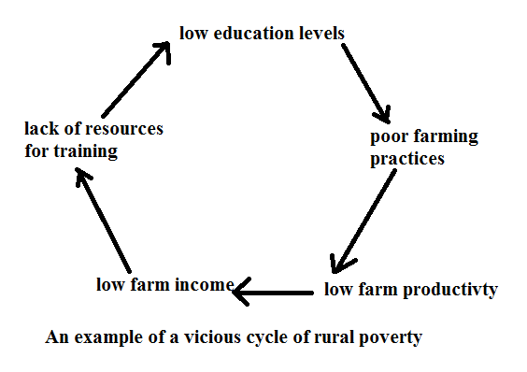
Extension breaks vicious cycle by
- Training the farmers
- Improving the welfare of farming families
- Promoting income distribution
- Promoting sustainable use of farming (natural) resources
- Production credit services
- Agricultural credit is the amount of money that a financial institution is prepared to lend a farm
Importance of agricultural credit
- Increasing agricultural production if it is used to buy the inputs which increases crop yield
- Increasing income per unit of given resources if the credit is invested it to increase the output per animal
- Improving nutrition and food security among farmers because high farm income enables farmers to buy nutritious food for their families
- Improving welfare of farmers through increasing farm income helps farmers to pay for the necessities for family such as medicines and household goods
- Increasing employment opportunities for rural people through the credit helps farmers to expand thereby employing more worker
- Employing the poverty cycle among farmers.
Examples of agencies that provide credit in Malawi
- Commercial banks such as national bank of Malawi
- Cooperative societies such as Savings And Credit Cooperative Societies (SACCO)
- Malawi Rural Finance Company. Branches are located in every (EPA)
- One acre fund
- Non-institutional agencies such as traders, friends and relatives
- Agricultural infrastructural services
- The term “agricultural infrastructure” refers to large scale basic physical and organisation facilities needed to support the operation of farm enterprise.
Examples of agricultural infrastructure include
- Transports networks such as roads and bridges, rail networks and pedestrian walkway
- Communication systems such as postal, telephone, internet, television and radio stations
- Water supply systems
- Power(electricity) supply system
- Food storage facilities such as the network of grain silos located in the regions and districts
- The networks of agricultural experiment centres and research stations spread throughout the country
- The networks of ADMARC markets and cattle markets located in all extension areas
- Livestock protection infrastructures such as the networks of dip tanks
Ways in which agricultural infrastructures are important
- Facilitating the transportation of farm inputs
- Increasing yields in agriculture through irrigation helps the farmer to obtain high yields.
- Enabling the transportation of farm produce to markets
- Promoting use of improved technology through rural electrification helps farmers to use motorised water pumps for irrigation to increase production
- Attracting and supporting manufacturing companies to set their industries near farmers. This encourages farmers to increase crop and livestock production.
- Promoting agricultural trade through good communication systems
- Facilitating dissemination of agricultural information when roads are good
- Improving farm income. Good transport system reduces cost of transport, production and marketing.
Agencies that provide infrastructure services that support agriculture in Malawi are
- Rural Infrastructure Development Programme(RIDP) focusing on roads and irrigation infrastructure
- Ministry of Transport And Public Infrastructure
- National Roads Authority
- Malawi Rural Development Fund(MARDEF)
- Ministry of Irrigation and Water Development
- Department of Veterinary Services
- National Water Development Programme
- Processing services
- Processing involves changing the form of agricultural produce to a form which consumers prefer.
Importance of agricultural processing services to the growing population
- Creating market where farmers can sell their produce and obtain an income, which encourages farmers to produce more for growing population
- Adding value to the produce so that famers can gain more from selling the products
- Providing employment to the population engaged in processing the produce
- Increasing shelf life of the produce so that it can be kept in storage for long periods without loss in quality, for the growing population to enjoy.
- Improving the taste of edible produce for the growing population
Processing agencies and their raw material and products
Processing agencies | Agriculture produce | products
Universal industries Ltd | Cassava, potatoes | Crisp
Universal industries Ltd | Groundnuts | Cutter, tambala nuts
Universal industries Ltd | Wheat, milk, eggs | biscuits
Malawi dairy industries | Milk | Yoghurt, butter, cheese
bakhressa | Maize | Maize meal, stock feeds
Rab processor | Maize | Stock feeds
Rab processor | Rice | milled
Chibuku breweries | Maize | Chibuku beer
nail | Chillies, peppers | Abale samalani hot chill
nail | tomatoes | Tamato sauce
Agro-feeds | Maize, soya beans | Stock feeds
Malawi mangoes Ltd | Mangoes, bananas | Fruit juice

- Marketing
- Means the whole range of activities which are involved in transfer of a commodity from point of production to point of consumption.
Some marketing activities

- Buying
- Selling
- Grading of the products
- Transport he produce
- Storing the produce

- ADMARC is mandated by parliament to carry out the various marketing functions. ADMARC PLAY THE FOLLOWING ROLES
- Planning, monitoring and regulating crop production
- Licensing crop production for example tobacco
Importance of agricultural marketing services
- Provide inputs to the farmers
- Providing an income to farmers after selling their produce
- Adding value to farm produce after grading
- Providing foreign currency after exporting the produce
- Distributing good and services though the transport function of marketing
- Encouraging farmers to use resources wisely to produce more and better quality products
Importance of the agricultural development agencies and their services to the growing population
- Promoting food security by helping the farmers to use improved inputs and methods of growing crops and raising livestock for high yields to make more food available to the growing population
- Increasing cash income for rural farmers by promoting modern farming technologies and practices to make agriculture more profitable,
- Increasing raw material production for agro-based industries: the support from agricultural development agencies and their services results in increased yield which is supplied to agro-based industries
- Improving employment opportunities by employing people on farms and the urban population find jobs in agro based industries.
- Improving government revenue through increase yields and revenue for the farmer on which government charges taxes to fund public services such as hospital and schools.
- Increasing foreign reserves after exporting crops such as cotton, tobacco, tea and groundnut which is used for importing various goods.
- Regulating production levels of certain crops in order to raise prices
- Providing efficient transport system to carter for perishable crops like tomatoes so that they do not go bad while in transit.
- Providing credit facilities to farmer to enable them increase the volume of production and hence more food to growing population
- Encouraging bulk selling of commodities by small scale farmers so that they can earn more to meet the domestic demands.

UNIT4 FARM RECORDS
- Farm records: refer to the systematic entries of various farm business activities and transaction including data on finances and inventory the farm has for certain period of time.
- Depreciation: this is loss of value of the item over time
- Salvage value: this is the value of asset after at the end of lifespan
- Obsolesce of the machines: this occurs when the value of an asset falls results of an asset becoming out-dated or the invention more efficient asset or discovery of a new fashion or process e.g. a discovery of an advanced computer, water pump, etc.
Types of farm records
- Depends on the type of information that is being dealt with.
- There are three types of farm records and these are

- Inventory records
- Production records
- Financial records

- Inventory records
- An inventory is a list of all assets of the farm
- It includes fixed assets like building, sheds and fences, machinery, tools, equipment and livestock It should be taken at the end of farming year usually in September when they is less work on the farm.
- Assets are things which can be converted into cash
Table 1 below shows a farm inventory record
Item | Quantity | Date Acquired | Original Cost(Mk) | Remarks
Cattle | 7 | 13/11/12 | 900,000 | Bought from research station, need artificial insemination(AI)
Sheep | 42 | 21/06/12 | 420,000 | Bred on farm, replace male, inbreeding
Hand hoes | 11 | 13/03/11 | 50,000 | Bought new, not adequate
plough | 1 | 24/09/13 | 1, 230,000 | Bought new, adjust discs
Spray race | 1 | 16/09/13 | 650,000 | Constructed, ready for use
STEPS INVOLVED IN TAKING AN INVENTORY
- Count the items physically.
- Physical measurement of, for example, size of land, buildings and other structures, and available crop.
- Estimating the value of assets using the present market prices.
- When estimating the present market value of the equipment and machinery, it is important to consider depreciation( loss of value of the item over time)
Lifespan: period an item is expected to be in use and its operation is efficient.

Ways of calculating depreciation

- Straight-line method
- Reducing balance method
- Sum of the digits method

- Straight line method
- The book value is found by subtracting a fixed value each year.
An example
The cost of an item is estimated at K9, 000 and its estimated salvage value is K1000 and the last span is 8 years.
$$depreciation per annum$$
$$=\frac{cost of asset-estimated salvage value}{estmated number of years of life of an asset}$$
Example
$$depreciation per annum=\frac{K9,000-K1000}{8}K1000 PER YEAR$$
Table 2 straight line method
Year end | Straight line annual depreciation (MK) | Remaining book value of the machine at the end of each year
1 | 1000 | K9,000-K1000=K8000
2 | 1000 | K8000 -K1000=K7000
3 | 1000 | K7000 -K1000=K6000
4 | 1000 | K6000- K1000=K5000

- Reducing balance method
- The scrap value varies from year to year
$$depreciation for the last year=last but one book value-the scrap value,$$
$$depreciation for the fourth year=third year book value-scrap value$$
Year end | Reducing balance annual depreciation at 25% | Remaining book value of the machine at the end of each year
1 | 25% of K9 000=K2,250 | K9000- K2,250= K6,750
2 | 25% of K6,750=K1,688 | K6,750- K1,688= K5,062
3 | 25% of K5,062=K1 266 | K5,062- K1 266= K3,796
4 | 25% of K3,796=K949 | K3,796- K949=K2, 847
- Sum of digits method
- The digits are summed up
- The total becomes the denominator used for solving depreciation
- Before calculating depreciation, subtract the scrap or salvage value of the capital item. The value that remains is called depreciation value or depreciable property
Table 3 sum of digits method
year | Sum of digits annual depreciation | Remaining value/book value of the machine at the end of each year
1 | 3/6 of K8,000=K1778 | K9,000- K1778=K7,222
2 | 2/6 of K8000=K1556 | K7,222- K1556=K5666
3 | 1/6 of K8000=K1333 | K5666- K1333=K4 333
∑=6 | K4 667

- PRODUCTION RECORDS
- Show raw amount of yield from crops and animals
- Tells the inputs used in producing a crop or raising animals and the farm produce or outputs
- Farmers use both variables which vary with crops grown and animal raised. Fixed cost is use for a long time e.g. building and equipment, permanent labour.
- Examples of productions records that a farmer can keep are as follows
- Egg production record
date | Number of layers | Number of egg collected | Number of egg broken | Number of egg not broken | Laying percentage | remarks
01/02/17 | 200 | 150 | 10 | 140 | 75% | Low yield
03/02/17 | 200 | 200 | 15 | 185 | 100% | High yield
Importance of the record
- Helps the farmers to know the total number of eggs laid
- Helps the farmer to detect if theft occurs
- It can also help the farmer to reveal weakness in handling the eggs if too many are broken so that the correct measures can be put in place
- Health record

date | Number of animals | symptom | Disease | treatment | Drug | Veterinarian | cost | remarks
Importance of the record
- Help to determine health of animals that can be selected for breeding
- To determine animals that can be culled/isolated/treated
- To calculate costs of treatments
- Livestock number records
- Is the record of number of livestock on the farm at the begging and at the end of the year taking into account of those that were born, dead or slaughtered
livestock | Number at the beginning | Number bought or received | Number born | total | Number died | Number sold/slaughtered | Number at the end
pigs | 300 | 20 | 40 | 360 | 5 | 5 | 350
rabbit
Importance of the records
- The farmer will know the number of animals died since this can reveal weakness in the management
- Helps the farmer to know the number of animals so that he can buy feed, vaccinate and provide enough space.
- Helps the farmer to know the number of animals so that he can detect theft
- Vaccination record

disease | Name of vaccine | Date 1 | cost | remarks
Importance of the record
- Helps the farmer to know the types of vaccine for the specific disease
- Helps the farmer to calculate cost of vaccine so that he can budget
- Reminds the farmer about the last date of vaccination since must be even regular interval effective control

- Sheep breeding record
Number of ewes | Service period (month) | Lambing date | Number of lambs born | Lambing percentage | Number of lambs weaned | remarks
Importance of the record
- Helps to know number of lambs born and determined whether the animals is more productive or not
- Helps the farmer to know expected date for parturition so that he can get prepared
- Pregnancy test result can assists the farmer to predict which animals are not fertile so that they can be culled.
- Date of service can assists help the to predict date of calving and get prepared
- Calving interval helps the farmer to know cow with a long calving interval in order to cull
- Crop production records
Crop planted | Date of ploughing | Date of planting | Fertilizer used | Amount of bags | Harvesting date | remarks
Maize | 21/01/2017 | 10/11/2016 | 23:21:0+4s | 4 | 07/06/2017 | Good harvest
soya | 11/01/2017 | 11/12/2016 | Urea | 2 | 03/05/2017 | Good harvest
Importation of field operation records
- Helps farmers to know timing for various operations so that they can plan for future
- Helps the farmer to know the number of the labour required so that he can hire enough labour.
- Financial records
- Refers to written in about money paid into the farm or paid out of the farm.
Information kept in financial records
- Expenditure
- Purchase: a record of funds spent for buying items such as farm inputs
- Expenses: funds paid out for services offered to the farm such as salaries/wages, payment and bills
- Income
- Sales: cash obtained after selling farm produce including value of crops eaten by the farmer,
- Receipts: cash received from services offered by the farm such as hiring out a tractor to another farmer who pay for the service.
- debtor and creditors
- Debtors are borrowers. People who owe the farm money e.g. people may collect farm produce and promise to pay back later.
- Creditors are people or companies owed money by the farmer e.g. the farm may obtain inputs and promise to pay back later

- profit or loss
- Also known as trading account. This differs form the cash book because it allows opening and closing of valuation. Depreciation must also be included.
Example: profit and loss account of Mr Chirwa
Sales and receipts | Amounts(mk) | Purchase and expenses | Amount (mk)
Maize sales | 5000 | Opening valuation | 2000
Soya sales | 2000 | Chemicals | 1500
Potato sales | 1000 | Labour | 3000
Closing valuation | 3000 | depreciation | 1200
Total income | 11 000 | Total expenditure | 7700
 |  | profit | 3300

- statement of assets and liability(balance sheet)
Examples of financials records
- Cash book
Sales and receipts |  |  |  | Expenditure and expenses
date | detail |  | Amount(MK) | date |  | detail | amount
1/2/14 | Balance b/f |  | 4000 | 2/2/14 |  | Bought 3 bags layer mash | K3600
10/2/14 | Sold 2 bags of maize |  | 5 000 | 11/2/14 |  | Bought 5 bags of fertilizer | 4800
15/2/14 | Sold 20 trays of eggs |  | 4800 | 29/2/14 |  | Bought hoes | 2400
22/2/14 | Sold carrots |  | 1200 | 23/2/14 |  | Bought broiler finisher mash | 6000
25/2/14 | Sold broilers |  | 10000 | 27/2/14 |  | Bought actellic | 4000
28/2/14 | Sold green maize |  | 8000 | 28/2/14 |  | Bought poultry vaccine | 2000
27/2/14 | Sold milk |  | 12000 | 28/2/14 |  | Bought dewormer | 3000
 |  |  |  | 28/2/14 |  | Balance carries down | 19 200
 | Total |  | 46 000 |  |  |  | 45 000
28/2/14 |  | Balance brought down | 19 200

- Balance sheet
- Balance sheet is a statement of all the first assets and liabilities of a business at a specific time usually taken on the last day of the financial year to show net worth or net capital of the farm. This account shows the value of all assets including cash and the value of liabilities e.g. loan and items delivered but not paid for.
- When assets exceed or equal to liabilities the farm is insolvent or bankrupt
Example of balance sheet for Mr Chirwa
liabilities | Amount (MK) | assets | Amount (MK)
Bank loan | 12000 | Cash in hand | 30000
Debt payable | 5000 | Cash in bank | 4000
Tax payable | 50000 | Land value | 3500
 |  | Value of fertilizer | 2500
 |  | Value of barns | 7000
Net capital (net worth) | K67 000 | Value of farm equipment’s | 47000
The farm is bankrupt because total liabilities exceeds total assets
REASONS FOR KEEPING FARM RECORD
- Help in planning and budgeting. this will enable a farmer to make appropriate choices and decisions in the farm/
- Provide history of what has been happening on the farm. It can be used for comparison
- It is required by financial institution before any loan can be approved to determine the need and capacity of the farmer to repay the loan as well as to determine whether the farmer can benefits from the credit if advanced.
- Adequate farm records avoid being overtaxed because tax will be based on only on the actual farm profits.
- Determine the financial status of the farm to know whether is credit worthy or not
- Help in proper management of various routine livestock or crop production practices e.g. dates of calving, vaccination, harvesting
- A comparison of the relative profitability of different crops and livestock enterprises will suggests which enterprises should be expanded and which one should be reduced or even eliminated to increase farm profits
- For comparison purposes between farmers dealing with the same enterprises. This helps to discover the cause for the difference
- They help the farmer when to breed animals
- Help the farmer to calculate on how tax to pay

UNIT 5 BUDGETING
- Budget is an estimate of expected costs and returns of business or enterprise
- Farm plan is required for one to prepare a budget
Definitions of farm budgeting
- The physical aspects of farm planning when expressed in monetary terms
Types of farm budgets
- There are three types of budgets and these are
- Partial budget
- Break-even budget
- Complete budget
- Partial budget
- Partial refers to estimating the return for a part of business i.e one or few activities for example
- To estimate additional costs and returns from growing one hectare of hybrid maize in place of local maize
- To estimate additional cost and returns by adopting foliar application of chemical fertilizers instead of soil application.
Four important questions when preparing partial budget
- What extra cost is to be incurred?
- What present/existing income or revenue is to be forgone or given up?
- What present costs will no longer be incurred?
- What extra income is to be earned
Components of a partial budget
- Increase in income (extra income)
- Reduction or elimination of costs (saved costs)
- Increased in costs (extra costs)
- Income forgone (opportunity cost)
- A positive net change indicates that farm income will increase due to change and farmer can change the enterprises since it is profitable, while
- A negative net indicates the change will reduce the farm income so a farmer should not just maintain the original enterprise
- Partial budget has two columns and see the examples of partial budget below
Examples of partial budget
Mr Phillip chirwa has two hectares of land on which he grows NSCM41. He however wants to make the following changes.
- To apply 4 bags of urea instead of 6 bags per hectare at k1 300 per bag
- To sell 50 bags of maize at k1000 per bag to chibuku products limited instead of k850 per bag to ADMARC
- To store maize in 50 sack at k30 each instead of storing it in the nkhokwe
- To spend k500 instead of k300 on actellic
- To spend k600/ha instead of k300/ha on casual labour
- Prepare a partial budget for Mr Chirwa
Cost/loss | Gain/income
1.Extra cost  - 4 bags of urea @ k1300=8×k10, 400  - Actellic @ k500  - Casual labour =K600×2=K1200  - 50sacks@k30each=k1500 | 3.extra income  - 40 bags of maize at K1000=K40,000
Subtotal=k13, 600 | Subtotal =k40,000
2Opportunity cost  - 40 bags of maize @ k850=k34, 000 | 4.saved cost  - 6 bags of urea @ k1300/bag=6×2×1300=k15,600  - Casual labour @ K 3000×2=K600  - Actellic=k300  - Nkhokwe =nill
Total cost=k37000 | Total income=k56500
Analysis= total income-total costs

- Should Mr Chirwa go ahead with his plans? Explain your answer.
= should change because total incomes outweighs the total cost and this means that the change is profitable
= or should change since the net change is positive and this implies that the change is profitable
Sections of partial budget
- Has three main sections

- Costs
- Benefits
- Analysis

- If the total costs outweigh total benefits which mean the change is not worthwhile or profitable hence the farmer should just maintain the original enterprise.
- But if the benefits exceed costs, then the change is profitable
Format for partial budget
PROBLEM(PROPOSED CHANGE)
Section 1 costs(extra cost) | Section 2 benefits
A .additional costs(these will be the costs incurred as a result of growing a new commodity or using a new practice) | C additional returns ( these will be the returns received as a results of growing a new commodity or using new practice)
Sub-total | Sub-total
B reduced return(opportunity cost) (these will be the returns that are given up as a result of no longer producing the current commodity being grown or practice being used) | D reduced costs ( these will be the costs that will no longer be incurred as a result of giving up the current commodity or practice for a new one)
Total cost (A+B) | Total Benefits (C+D)
Section 3: analysis
Net change in profits (Total benefits-Total costs)
Benefits Costs (total benefits$÷$ total costs)
USES OF PARTIAL BUDGET
- Introduce a new enterprise without necessarily changing other enterprises
- Change one enterprise for another-sometimes referred as substitution
- Expand the existing enterprises or make additions to existing enterprises e.g. increased the area for crops or livestock herd for beef, dairy, broiler, egg production, sheep, goats
- Buy new farm machinery or equipment
- Adopt a change in method of production, for example, introducing a milking machine instead of hand milking.
- Participating in government program
Limitation of partial budgeting
- it is restricted to evaluating only two alternatives
- The results obtained from partial budget are only estimates and are only good as the original data is entered. If you enter in accurate information in the budget, you receive inaccurate information.
- does not account for value of money now and in future
- Only provides an estimate of the profitability of an alternative relative to current operations but does not provide estimate of the absolute profitability of business.
- Costs and returns that are not affected by the intended change are not included
- Break-even budget
- Break-even level or break-even point represents the sales amount in either unit or revenue terms-that is required to cover total costs(both fixed and variable cost)
- The total profits at breakeven point is zero
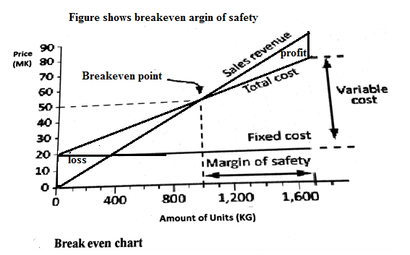
- Break-even point occurs when revenues equals costs. This is this is the point at which all the enterprise’s costs have been covered by earned revenues.

Types of breakeven point
- Break even based on sales: this happens to valued-added enterprise that is selling produce, or other proceeded foods, products in large quantities
- Break even based on units: a value added enterprise that sells defined units of products, such as limited number of cattle, goats or sheep.
- In any farming business, the break-even point is not affixed number. The value changes as farming business moves forwards with its operations, gains, experience and better understanding of both its profits potential and operating expenses.
- Break even yield: this is the yield needed to cover the costs given the expected price, enterprise income and other income such as in kind payments
- Breakeven price: this is the price needed to cover the costs given the expected yield and income.
$$breakeven yield=\frac{total costs}{output price}$$

$$breakeven price(B.E.P)=\frac{total costs}{expected yield}$$

- Break-even is only possible if firm’s prices are higher that its variable costs per unit
- In economics, business and cost accounting, the breakeven point is the point at which total cost and total revenue are equal. There is no net loss or gain and one has broken even i.e. both sides of the equation of the equation are the same.
- If it not possible to break even yet the farmer wants to embark on the business, then he/she can do the following.
- Try to reduce the fixed costs (by negotiating land rental for example or keeping better control of telephone bills or other costs)
- Try to reduce variable costs through inputs substitution-adopting organic farming)
- Increase the selling price of maize. This can be achieved through selling of maize in times of scarcity.
- The aim these three points highlighted above is to reduce break-even and increase profits.
Purpose of break-even budget
- The main purpose is to determine minimum output that must be exceeded in order to make profit.
- It also serve as a rough indicator of earnings(income) impact of marketing activity
- It provides a dynamic view of the relationship between sales, costs and profits.
- It also gives a manager a chance to understand when to expect to break even ( by linking the percent to when in the week/month this percent sales might occur)
- Complete budget
- Also known as whole farm budget
- Looks into every detail of the farm
- It includes both fixed and variable costs
- Prepared when farmer wants to start a farming system business
Complete budget is prepared when
- A farm is prepared for a new farm
- When drastic changes are suggested in the plan of the existing pattern on established farm.
- It can be prepared for short run (annual budget and for long run. Example of a complete
 | maize | cassava | tea | Rice
Yield(kg/ha) | 400 | 450 | 800 | 2000
Price(k/kg) | 200 | 50 | 200 | 25
Gross income (mk) | K80 000 | 22 500 | 160 000 | 50 000
Variable costs (MK)
Seeds and fuel | 1000 | 500 | 800 | 500
Fertilizer and transport | 8 000 |  | 10000 | 20 000
Pesticides | 5 000 | 150 | 1000
Casual labour | 100 | 150 | 200 | 80
Total variable costs (TVC) | 14 100 | 800 | 12 000 | 20 580
Gross margin/ha | 65 900 | 21 700 | 148 000 | 29 420
Fixed costs for all the four enterprises(maize, cassava, tea and rice) MK
Regular/permanent | 20 000 | 20 000 | 20 000 | 20 000
Rental and fuel | 5 000 | 5 000 | 5 000 | 5 000
Depreciation | 250 | 250 | 250 | 250
Maintenance & repair | 3000 | 3000 | 3000 | 3000
Land tax | 3000 | 3000 | 3000 | 3000
Loan tax | 2000 | 2000 | 2000 | 2000
Administration & office expenses | 1000 | 1000 | 1000 | 1000
General overheads like licences and car expenses | 8000 | 8000 | 8000
Total fixed costs | K42 250 | K42 250 | K42 250 |  | K42 250
Study the table above thoroughly and answer questions that follow.
- Find the two crop enterprises that have the highest gross margin (GM)
- Which crop would advise the farmer to grow the crop you mentioned in 1 above?
- Why would you advise a farmer to grow the crop you have mentioned in i above?
- Which crop would be the worst for the farmer to grow?
- Calculate the whole farm gross margin.
- Work out the whole farm profit.
- Gross margin= the difference between gross income and variable costs
- Profit=the difference between gross margin and fixed costs
Table 11 difference between complete budget and partial budget
 | Complete budgeting |  | Partial budgeting
1 | The whole farm is considered as one unit | 1 | It is adopted when the minor aspect of farm organisation is touched
2 | All the aspects like crops, livestock, machinery and other assets are considered | 2 | It is practiced within the existing resources structure of the farm
3 | Both fixed and variable costs are calculated for working costs and returns | 3 | Only variable costs are considered
4 | Net income is estimated by deleting fixed costs and costs of variable inputs from the value of the product | 4 | Net income is estimated by deleting only costs of variable inputs from the value of the product
5 | It requires more efforts and time preparation | 5 | It requires relatively less efforts and time and time for preparation
Steps involved in complete budgeting
- A farmer should decide on what to produce based on farmer’s skills
- Estimate inputs requirements
- Make an estimate of the expected yield
- Make an estimate of prices for the yield
- Estimate fixed costs of buildings, machinery depreciation
- Calculate total cost
- Calculate total revenue
- Calculate net revenue

UNIT 6 FARM BUSINESS DECISION MAKING
- The idea of decision making on farm is to enable the farm maximise profits. Therefore farmers have to make the right decisions at all times so that even when it is difficult for most farmers to prosper and stand out and make profits.
Examples of farm decision

- what to produce
- how to produce
- how much to produce
- when to produce
- where to buy and sell

ECONOMIC PRINCIPLES IN FARM BUSINESS DECISION-MAKING
- opportunity cost
- comparative advantage
- substitution of inputs
- diminishing marginal returns

- opportunity cost
- This is the value of forgone alternative. When a farmer decides to produce maize instead of groundnuts, the difference in value between groundnuts and maize is forgone alternative and therefore an opportunity cost.
Importance of opportunity cost
- Evaluating options: this helps to assess the options before making the final decision.
- Choosing wisely: by considering of an action, the farmer is guided to make rational choice.
- Efficient use of scarce resources like land , capital and labour
- Maximising satisfaction: the farmer should select alternatives that give highest returns.
- Comparative advantage
- Farmers must concentrate and take advantage of enterprise which bests suits the environmental conditions of their area.
- For example, farmers in Tsangano have comparative advantage over the farmers in hot areas of Malawi in production of Irish potatoes
- Comparative advantage also works where the farmer has skill for particular enterprises. As a result farmers are advised to choose the enterprise which they are able to handle due to skill or those enterprises which best suits their environment.
Advantage of the principle of comparative advantage
- It encourages farmers in each area to select at least one product that suited to their area and concentrate on and offer it to the market, trading, nationality or internationally.
- Substitution of inputs
- Substitution means replacement of resources
- The principle of substitution of inputs states that it is beneficial for a farmer to substitute an input, resources, technology for another if it is
- Reduces costs but produces the same level of yield
- Has the same cost but increases yield.
Examples of input substitution include the following
- Weeding by hoeing out the weeds or spraying herbicides
- Feeding layers on a commercial ration or a home mix
Importance of the principle of substitution of inputs
- Guides the farmer in choosing the cheaper or profitable inputs, resources or technology of production
- Helps the farmer answer the farm management questions on how to produce.
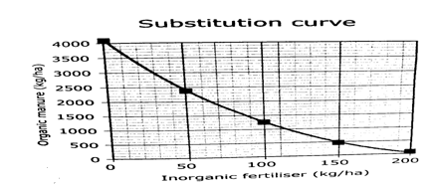

- Diminishing marginal returns
- The states that an increase in one input (with everything remaining constant), will increase output, but after a point, the extra output resulting from the additional inputs, will become less.
- The law is clearly advising the farmers to decide on the right amount of inputs for every enterprise because too much inputs is dangerous
- Diminishing: means declining or getting reduced
- Marginal means additional or incremental
- Return means output or yield
Table showing the relationship between level of inputs (fertiliser) and its corresponding yields
amount of seeds(kg/ha) | marginal yields(kg/ha) | stage of marginal returns
0 | 0 | increasing marginal returns
1 | 11 | increasing marginal returns
2 | 20 | increasing marginal returns
3 | 22 | increasing marginal returns
4 | 19 | diminishing marginal returns
5 | 13 | diminishing marginal returns
6 | 7 | diminishing marginal returns
7 | -1 | negative marginal returns
8 | -8 | negative marginal returns

The stages of the law of diminishing marginal returns
- Stage of increasing marginal returns
- The additional input causes the marginal output rises. In this level output is performing wonderfully due to availability of other productive resources.
- Stages of diminishing marginal returns
- In this stage, the additional input causes the marginal output to lessen because of competition between production resources resulting in reduction of the marginal yield.
- Stage of negative returns
- This stage stat when the additional output becomes too excessive compared to fixed resources causing the marginal output to be negative.

Importance of the principle of diminishing marginal returns in decision
- Helps the farmer to;
- Understand the relationship between level of inputs and level and production so that the farmer can decide on the best level of inputs to use for optimum production
- Identify the point(stage) when diminishing returns set-in
- Deal with increasing marginal costs that would otherwise arise from increasing levels of inputs
- Avoid waste of farming resources (that would even result in negative returns)
- Understanding that there is a point or stage where benefits of doing something will slowly diminish
- Understanding that spending and investing more and more in a product where other factors remain the same mean that the returns will eventually begin to diminishing in long run

UNIT 7 ENTERPRISE COMBINATIONS
- A farm enterprise: is a single type of crop or livestock that produce a marketable products or commodity.
Some examples of farm enterprise in Malawi
- Goat farming
- Broiler production
- Sheep production
- Dairy farming
- Maize production
- Groundnut farming
- Tomato farming
- Cabbage farming
- Cassava farming
- Sugarcane farming
- A farmer can decide to have two or more enterprises. Such combinations of farm enterprises can be made up of ;
- Crop enterprises only
- Livestock enterprise only
- Crop and livestock enterprises
- The enterprise can be combined because of their capacity to benefits each other or benefit the farmer.
Factors to consider when combining enterprises
- Profitability of an enterprise: farmers choose those enterprises whose total profit can be significantly high.
- The farmers’ food requirement; food is a priority hence resources should be spared for food crops before thinking of cash crops. An adult per year consumes 300kg of maize while a young person under the age of 18 consumes 150kgs.
- Resource availability: these include
- Land: is scarce due to increase in population. This determines the type of enterprise to venture into and how many enterprises to combine due to the nature of the soil(slope and type of soil0
- Labour: this is the amount of work done by human and this limits the size of enterprise due to increase in labour demand for some months on some crops. So farmers have to make a labour profiles showing how labour is distributed during production period.
- Labour is estimated in man-days. A adult male supplies 25 man days per month, an adult female supplies 16.7man days while child supplies 7.5 man days
- Capital: refers to both live and dead stock on the farm used for production and the money needed to run the farm. It is always scarce so farmers have to use it economically.
- Management: this is the inherent skills the farmer has in decision making and farmers have to make sound decisions on what most economical enterprise to combine and how well resources can be put into use.
- Nature of enterprises. Enterprises fall into three major types
- Competitive enterprise: those competing on production resources
- Supplementary enterprises: one is the main while the other one is just an additional one
- Complementary enterprise: those enterprises help each other.
- Opportunity cost: the farmers should select the best enterprise in order to make a lot of profits.
- Comparative advantage: this principle urges farmers to concentrate on those enterprises which perform well in their areas. This ensure high productivity and profit maximisation
- Risks and uncertainties: risk is the difference between what you expect and the outcome while uncertainty is a state of imperfect knowledge. Tobacco for example is a high risking crop due to price instability on the market. While drought, hall and pest and diseases outbreak are examples of uncertainties. A risk is predicted and ensured while uncertainty cannot be predicted and ensured.
Ways of safeguarding against risk and uncertainty
- diversification: .venturing into different enterprises with hope that not all will fail
- choosing enterprise that are of low risk
- buying an insurance cover so that when the enterprises fails beyond farmer’s control, the insurance company can compensate
- input substitution: farmers should not invest a lot into input rather should replace the expensive ones which less expensive one like organic manure this helps to reduce production cost.
- Flexibility in the methods of production: farmers are advised to use capital items which can easily be turned for different enterprises.
- Farmer’s ability: this has to do with the skills the farmers have in managing an enterprises.
Types of enterprise combinations
There are three;
- Competitive enterprise: compete for scarce resources like labour, land and capital. An increase in one causes a decline in the other. For example a farmer has 4 hectares of land and wants to combine maize and forestry; it means it means if he decides to increase maize enterprise, he must reduce land for forestry.
- Supplementary enterprise: one enterprise is the main while the other one is just an additional one. For example maize grown together with beans, beans supports maize with nitrogen which it fixes while maize provides beans with support. The farmer has not to reduce the size of maize enterprise in Oder to expand the bean enterprise.
- Complementary enterprises: these are enterprise which is combined to assist one another. Examples maize and climbing beans and another example can be duck and fish rose in a pond. Ducks provides manure to the pond while fish can be fed to ducks.

UNIT 8 AGRICULTURAL COOPERATIVES
- Agricultural cooperatives is a group of farmers who come together on voluntary basis for purpose of achieving a common goal for mutual economic benefits
Importance of agricultural cooperatives
- Produce or markets goods cheaply because they share the resources and expertise
- Secure loan from commercial banks because a group serve as a security
- Buy inputs cheaply since they buy in bulk and at wholesale price
- Benefits from economies of scale i.e. it is cheaper to produce a unit of commodity if it is mass produced
- Easily transport produce to market
- Bargain for better prices or selling conditions as a group
- Share storage and processing facilities
- They quickly adopt innovation by sharing expertise and knowledge
Principles for formation of agricultural cooperatives
- Should be legally constituted with guiding rules and regulation
- Participation is free, people are free to join or withdraw
- Should be impartial, non-partisan and non-religious
- Must be efficient and effectively organised
- Must be open to all farmers who share a common interest
- Should have enough capital/funds
- Organised and run according to democratic principles(one person, one vote)
- Must continually educate its members to improve their productivity and marketing skills
- Members managing the funds are skilled, trustworthy and highly motivated
- All members are committed to the cooperative and its success
- Should have adequate infrastructure (staff houses, offices, and storage facilities), personnel, transport, equipment and supplies.
- Should join from the local to the national level
- It must follow legal procedures of forming and registering a cooperative as follows;
- Minimum number of eligible persons t from cooperative being ten
- Elect an interim committee
- Draft the cooperative’s rules and by-laws (constitution)
- Articulate the objectives of the cooperative
- Suggest a name for the cooperative
- Apply for registration to the relevant agricultural authorities
Types of farmers’ cooperative
- Farm production cooperatives
- Marketing cooperatives
- Consumer cooperatives: a cooperative which buys inputs in bulk and sell to its members at subsidised price
- Savings and credit cooperatives (SACCO)

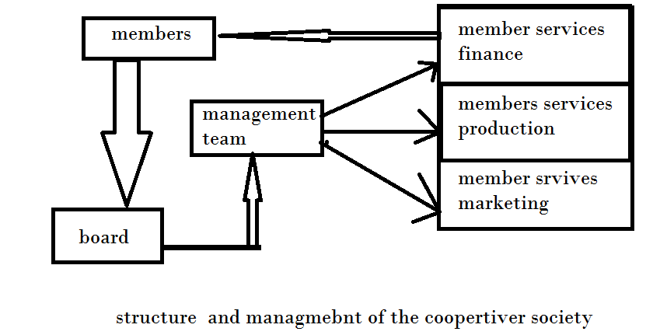Challenges of running agricultural cooperatives
- Lack of loyalty to the cooperative. this occurs when members fails to abide by their own rules and regulations on issues of repayment of loans and this brings quarrels and divisions within the cooperative
- Misuse of fund by executive members: this is a serious issue because members of the executive need to be trustworthy.
- Lack of sound economic base of the cooperative which makes it impossible for members to obtain loans and other benefits
- Lack of knowledge about the rights and obligations of members and they get frustrated when they don’t get what they think are their entitlements.
- lack of capital for the smooth running of the cooperatives like paying for labourers
- lack of infrastructure, equipment’s and transport and cooperative will suffer if these are not available
- Poor leadership and management-cooperative are run by board of governors and management staff on behalf of members and these must be transparent and accountable
- Lack of equity and equality among members. when choosing people for various position, there should be gender balance and equality between men and women
- Lack of social responsibility and lack of self-help spirit. members need the spirit of self-help and social responsibility in order to support and to encourage all members in success of the cooperative
- Lack of motivation and expertise among members and staff. All members should be highly motivated and be able to work with minimum supervision.
Solutions to the challenges faced in running agricultural cooperatives
- raising enough funds through membership through membership fees and getting loans through banks
- constructing the necessary infrastructure and purchasing equipment and vehicles
- Choosing reliable, honest, trustworthy and transparent leaders.
- proper supervision of the employed manager and other staff
- Employing staff with skills and expertise in accounting, book keeping and business management.,
- cultivating and encouraging the spirit of self-help and social responsibility among members
- training members, board members and management team on cooperative management , priciple4s, values, business management and planning
- ensuring that there is equal employment and participation among males and female members
- Members meet their subscriptions and high financial prudence by executive.
- Members must believe that the cooperative is their own and they cannot afford to see it fails since its failure is their failure.
- Lack of knowledge about rights and obligation of the members and this can be solved through orientation on their right and their roles.

UNIT 9 VEGETATIVE PLANTING MATERIALS
- There are many crops which cannot be raised using true seeds. However, these crops must also multiply so that they do not become extinct.
- Vegetative propagation: this is the production of new plants by using parts or part of an existing plant, without the use of the seeds.
- Also called asexual propagation
Vegetative planting material used | Name of crop(s) planted by the vegetative planting material
Stems | Sugar cane, cassava
Leaves | Cactus and flowers
Suckers | Banana
Tubers | Irish potato
Bulbs | Onion
Corms | Cocoyam
Rhizomes | Star grass
runners | Sweet potato, straw berry, star grass
Labelling parts of vegetative planting materials
      - Stem cutting
- Are pieces of stem that have buds at each node and that developed adventitious roots. These stems are used for field planting.
- Plants that can be propagated by stems include: sugarcane, Napier (elephant grass or Nsenjere) and cassava.
Procedure for propagating by stems
- Select the freshest uppermost parts
- Cut them into length of about 15-30cm using panga knife
- Each stem should have three nodes( research has shown that stems with three nodes has higher germination percentage than those having more or less nodes)
It is better to use three-node cuttings than single-node cutting in order to obtain.
- High germination capacity
- High initial plant vigour of the germinated shoots
- High sugarcane yield
      - Runner
- A stem which grows horizontally above the ground
- The stem must have the anode where buds are formed
- The buds grow into a new plant
- Crops strawberries, sweet potatoes and pastures such Henderson star grass can be propagated in this way.
      - Stem tubers
- Is an underground swollen portion of the stem
- The tuber acts as a food storage organ. Irish potato (European potato) is a tem tuber.
      - Suckers
- A sucker is a shoot (or tiller) arising from an auxiary bud at the base of a parent plant.
- Suckers are cut off or uprooted and planted elsewhere e.g banana suckers
      - Bulbs
- A bulb is the storage organ of vegetative planting material for crops such as onions, tulips and garlic
- The leaves contain lots of stored food.
      - Corms
- A corm is a thickened base of underground stem in which food is stored
      - Rhizomes
- Is thick horizontal underground stem.
- New shoots and roots grow from the buds on the rhizome. Ginger, bamboo and even banana can be propagated using rhizome.
      - Leaves
- Crops like begonias and African violet are examples
      - Branches(layering)
- Air layering
- A branch is plant wounded and the wound is covered with soil,
- the branch will usually develop roots
- While it is attached to the parent plant.
- It is then cut off from the parent and grown as a new plant.
- Ground layering
- A branch of tree is pegged down to the ground so that it can develop roots new shoot while it is still attached to the plant

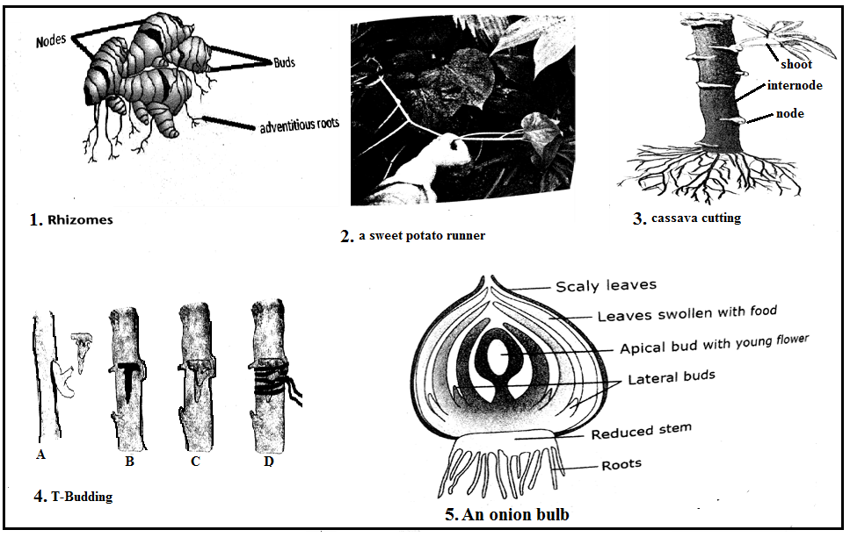
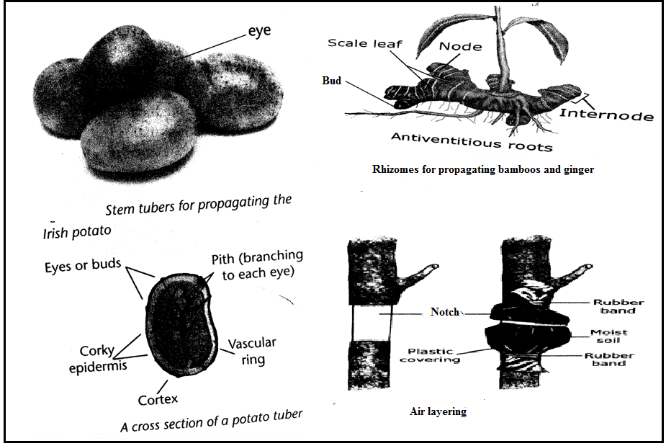

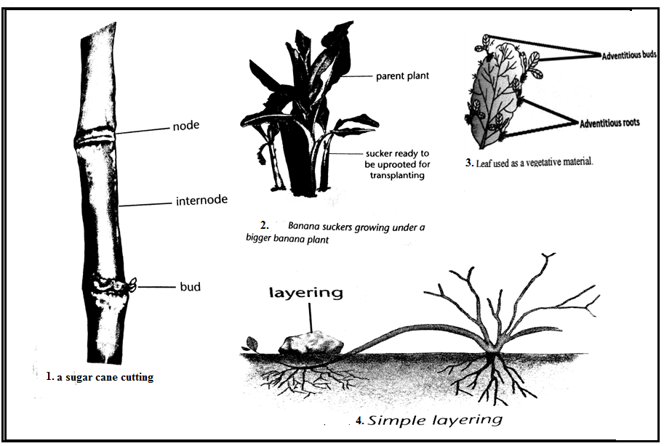
Methods used in vegetative propagation
- Budding
- This is the union of a bud with a root stock
- The bud is taken from a high yieidn tree of good quality
- The stock must be hardy and strong
Procedure
- A bud is sliced off from a mature branch of a desired tree
- A T-shaped cut is made on the root stock at a height of about 45cm
- The bud is inserted into the T-shaped cut to unite the cambium of the root stock and he bud
- The union is bound with a tape
- Layering
- This involves induction of the plant to produce roots and shoots on their stem while still attached to the main plant.
Procedure
- Bending and pegging the braches of a tree or shoots down to be ground
- The pegged point is covered up with rich humus soil while the end of the shoots is allowed to remain above the ground level
- Contact with the soil in this way causes the branches to develop roots at the point and eventually a new plant become established e.g. cocoa
- The stem is then cut used for further propagation
- Grafting
- It is the practice of joining two stems for continued growth as one plant. The part at which the plant parts join is called the union.
- The two parts that are joined are called the root stock and the scion
- The scion is the upper part of the union
- The root stock is the lower part of the union which is the part of the rooting system
Procedure
- Cut each plant in a slant or V-shape to provide large surface area for contact
- The plants should be of the same age and size so that the cambia surface are may be brought closely together
- Join the scion and the root stock
- Bind the union with a grafting wax to prevent entrance of the bacteria
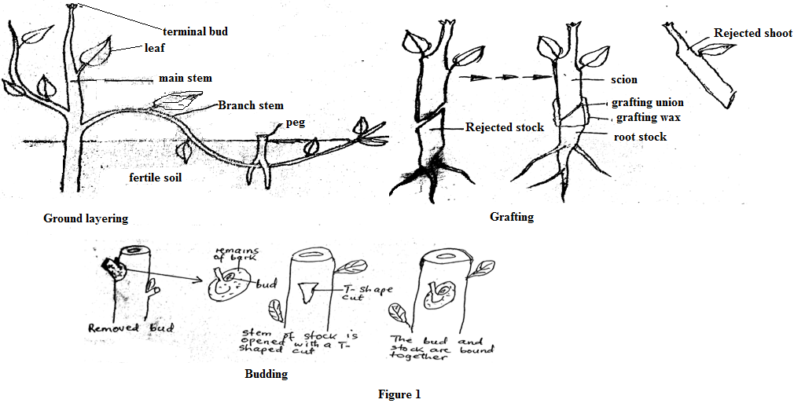
Advantages of vegetative planting material
- Vegetative planting materials are readily available to farmers from the previous crops
- Vegetative planning materials have enough food reserves that can be used to sustain growth of the new plant. This increases survival rate of the new plants.
- It ensures genetic uniformity as much the offspring resembles the parents.
- Reduces dormancy as it is the case with some seeds such as tomatoes which be dried first before they can germinate.
- They provide the only way of propagating crops whose seeds do not germinate or do not breed true.
- Plants propagated by this method grow faster and matures earlier than those established using seeds. This is because large amount of food reserves the vegetative planting materials have.
Disadvantages of vegetative planting materials
- They cannot be stored over a long period as is the case with seeds because they can wilt and eventually die
- They are usually bulky and therefore difficult to transport over a long distance.
- They need to be handled with care using transportation otherwise the growing points can easily be destroyed.
- There is a very high risk of transferring diseases from parents’ plants to the plants.
- It is difficult to introduce variation into the crops. As a result crop improvement becomes difficult.

UNIT 10 CROPPING SYSTEM
- Cropping system refers to pattern, techniques, procedures followed in the cultivation and production of plants
- Cropping system practiced by farmers include
- Monoculture
- Monocropping
- Continuous cropping
- Mixed cropping
- Crop rotation
- Bush fallowing
- Shifting cultivation
- Organic farming
- Agroforestry
- Monoculture
- Different crop are grown on a farm occupying separate plot each.
- Pure stand: is plot which carries only one crop at a time.
Advantages
- Mechanization is easy
- Eliminates competition from other crops
- Easy to use chemicals in pure stands (pesticides, fertilisers or herbicides)
Disadvantages
- There is less total yield per unit area as compared to mixed cropping
- Pest and diseases can spread more rapidly because there is no traps plants in the field
- Monocropping
- The farmer solely grow one crop on the farm and nothing else. While in monoculture a farmer can grow several crops but on pure stand.
Advantages
- It reduces the start-up capital because the farmer invest in one crop
- The farmers specialise in the management of the crop and as a result, it becomes very easy to perform the operations with precision.
- Crops productivity increases due specialisation because the farmers knows what to do and when
- A farmer makes a lot of profit since s/he enjoys economies of scale because it is associated with large scale farming.
- It is easy to mechanise since the entire farm has one crop
Disadvantages
- Pest and diseases spread very fast because the susceptible host is always available.
- There is much higher risk of total crop failure because farmers grow only one crop.
- If the farmer grows, non-cover crop, the soil is subject to erosion.
- There is rapid exhaustion of land because the crop uses nutrients from the same soil horizon.
- Continuous cropping
- This is a system of growing crops on a piece of land every year without fallowing. Most farmers practice this because they do not have large land holding for fallowing.
Advantages
- Ensures 100% utilisation of the land
- Conserves the soil since the land is under cover throughout the year
- Ensure food security or cash for the farmers from the crops harvested from all parts of the farm each year
Disadvantages
- Exhaust soil fertility since nutrient s are removed by crop each year
- Results in over-cultivation or cropping which destroys soil structure
- Results in multiplication of pests and diseases and some parasitic weeds
- Mixed cropping
- This means growing different crops on the same plot during the same growing season. It is also called Polyculture, Multicultre, Interplanting, and Intercropping. This system maximises land use.
Forms of mixed cropping
- Mixed intercropping
- Crops are mixed without any pattern in the field. Examples are crops grown by broadcasting.
- Row intercropping
- Intra-row cropping
- Two crops are grown on the same row (ridge) and crops may be sown on the same station or different. Examples are maize and beans.
- Inter-row cropping
- One crop is grown between the rows of another crop. In other words crops are grown on alternate rows or ridges.
- Relay cropping
- A second crop is sown on the plot while the second one is still growing or even maturing. This is also known as phase planting. Cassava can be planted in maize. This is common for maize and beans. The practise is successful where rainy season is longer than required by the first crop.
Advantages
- Saves labour since all operations are done once for all crops
- Saves land since it is used for more than one crop
- Increase total yield per hectare
- Reduces the risk of crop failure since the farmers rely on others crops if one fails
- Enables crops to benefit from one another (beans fix nitrogen which is use by crop while maize acts a stake for climbing beans)
- Reduces the spread of pest and diseases
- The mixture of the crops provides adequate soil cover to reduce soil erosion and weed growth.

Disadvantages
- Mechanisation is difficult since each crop has specific needs in terms of operations like ploughing and ridging
- Requires large starting capital to get different machines and farm structures for the different crops
- It is difficult to use pesticides, fertilisers or herbicides since used chemicals used on one crop may be harmful to another.
- Requires a wide range of knowledge and skills to manage different crops
- Different crops shade one another reducing the rate of photosynthesis.
- Crop rotation
- This is the practise of growing different crops(changing crops) on piece of land in particular sequence (order) every year.
- The farmer decides on the crops to grow, depending on
- Climate
- Soil type
- Amount of land
- Capital
- Labour
- Managerial ability
- The length of rotation depends on the crops to be grown, for example six year rotation a farmer should divide the land into six equal plots. Each crop return to its original plot after six years..
Example of crop rotation sequence
Year | PLOTS
1 | Maize | Cassava | Cotton | G/beans | Millet | G/nuts
2 | Cassava | Cotton | G/beans | Millet | G/nuts | Maize
3 | Cotton | G/beans | Millet | G/nuts | Maize | Cassava
4 | G/beans | Millet | G/nuts | Maize | Cassava | Cotton
5 | Millet | G/nuts | Maize | Cassava | Cotton | G/beans
6 | G/nuts | Maize | Cassava | Cotton | G/beans | Millet
Some of the principles farmers follow in allocating crops to plots are
- Alternating tap (deep) rooted crops with fibrous (shallow) rooted crops.
- Alternating leguminous crops (beans, groundnuts, peas) with non-leguminous (cereals, cotton, tobacco).
- Alternating heavy feeders(soil exhausting crops ) with light feeders
- Alternating crops that are resistant to specific diseases with susceptible crops to those diseases.
- Alternating crops with good soil cover with those having little soil cover.
Advantages
- Ensures that plants make full use of nutrient s from different layers in the soil
- Maintains or improves soil fertility if legumes included in rotation
- Controlling pest and diseases by breaking their life cycle
- Controls parasitic weeds which are host specific by depriving them of their host on the plot in some years (witch weed associated with cereals)
- Reduces soil erosion when cover crops are included in the rotation to cover and protect the soil against raindrops impact and run-off
- Ensures even distribution of labour demand throughout the year so that serious labour peak months may not occur.
- Spread financial risks over several crops.

Disadvantages
- Results in less farm income compared to monoculture (since some crops in the rotation may have low commercial value).
- Requires more land to accommodate the various crops
- Requires more labour since some crops in rotation needs more labour
- Requires skills in management of various crops which the farmers may not have.
- May not be practical where the farmer needs to use over 90% of land for staple food crop each year to meet family food requirements
- Bush fallowing
- Also called land rotation
- Means farming a plot, temporarily leaving it when exhausted to regain fertility, then returning to it later.
- The fallow period may be five to ten years.
Advantages
- Cheap, does not need a lot of capital from fertilizers
- Maintains soil fertility thought land fallow fertility
Disadvantages
- Encourages deforestation
- Increases soil erosion because land is left bare
- Requires a lot of land
- Shifting cultivation
- Land is cultivated for several years until yield become low due to soil exhaustion, and then it is abandoned for another one.
- No fertilizers are applied
- Nutrients are added in the form of ash (potassium and calcium) after burning.
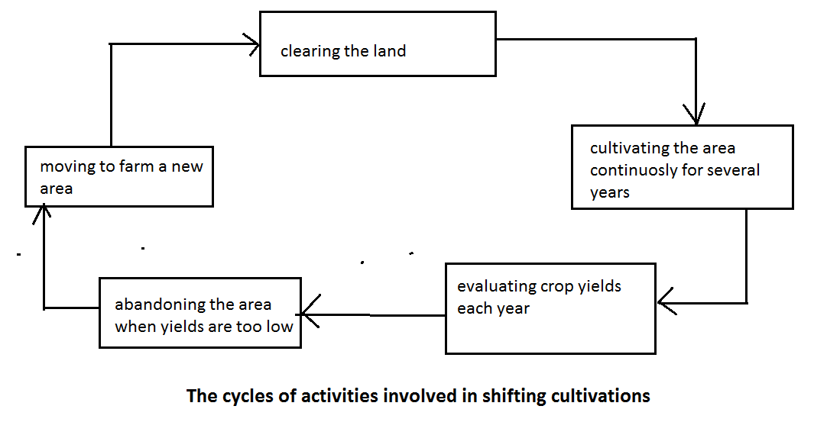 Advantages
- Cheap, does not require fertilizer
- Simple, it uses hand tools
- Controls pests and weed seeds through burning
Disadvantages
- Requires more land
- Low yields due to fertilizers application
- Burning destroys organic matter and soil nutrients
- May lead to soil erosion due to deforestation
- Organic Farming
- Also called biological/ecological farming
- It is the cropping system where crops are grown using organic inputs such as manure (organic fertilizer) rather than inorganic inputs like commercial fertilizers.
- Pest and diseases are controlled physically, culturally and biologically instead of chemically.
Advantages
- Prevents pollution of water reservoirs
- Protects useful insects(pollinators and predators of pests)
- Improves soil structure through organic manures
- Cheaper to make and apply organic manures
- Reduces chances of poisoning people
- Environmentally friendly
Disadvantages
- Organic inputs are usually slower than inorganic inputs
- Organic inputs may be readily available for large farms
- Agroforestry
- This is a cropping system in which agronomic crops are grown in association with forest trees.
- Trees are planted such that they leave a strip of land where agronomical crops are grown.
- They are usually planted either to the east-west directions so that sunlight can still reach the field crops.
- Most of these plants are leguminous trees used as livestock feeds such as leucamia, sesbania sesban(locally known as jerere) and
Forms of Agroforestry
      - Agrosilviculture
- Agro means fields crop, while silviculture means growing trees and shrubs
- Agrosilviculture is the practice of growing of fields’ crops and trees, shrubs together on the same piece of land.
- It involves planting rows of field crops to be followed by rows of trees. The spacing of the rows should be large enough to allow the crops access the sunlight.
      - Silvopastoral
- Trees are grown in association with pasture.
- The word is derived from silviculture and pastoral. Pastoral means rearing animals. Farmers can grow forests trees or fruits trees with pasture.
- 8-20 meters space for trees before the next strip of pasture can be enough.
      - Agrosilvilvopastroral
- Agronomic crops, pasture, trees or shrubs are grown together
Advantages of Agroforestry
- The farmer has a large source income base because apart from agronomic crops the farmer can sell poles. Fuel wood, timber.
- The farmers maximises the use of land resources. Since trees are deep rooted, they get their nutrients from deep horizon and bring them to the surface as the leaves fall and decompose.
- Helps to improve fertility through nitrogen fixation by legumes.
- Helps to control soil erosion. The roots open up soil their by encouraging water infiltration while at the same time their foliage intercepts rain drops before falling to the ground. In turn they help to conserve water
- The trees protect the crops from strong wind
- Legumes trees such as leucaena and sesbania sesban are good animal feed.
Disadvantages
- Agronomical crops may not produce high yield because of shading from trees.
- It cannot be practiced be practiced where land is scarce to carter for both trees and the fields crops
- There is high labour demand as the trees may need regular pruning to ensure that there is limited shade in the field of crops.
Cropping systems which can promote crop yields
- Examples are; crop rotation, mixed cropping, monocropping, monoculture and crop rotation. These give yields due to;
- Use of improved technologies such as use of inorganic fertiliser, pesticides, herbicides which promotes fast growth of crops
- The systems like monocropping produces high yields because farmers grow only the most suitable crop for the environment exploiting the principle of comparative advantage
- Specialisation which occurs in system like monocropping and monoculture enables farmers to become experts in their crop
- Control of soil erosion, pests and diseases by mixed cropping and crop rotation increases yields
- Maintenance of soil fertility by crop rotation and mixed cropping increases crop yields
Cropping systems which do not promote high crop yields
- Farmers use low levels of technology e.g. hand tools and do not apply fertilizer
- The land is cultivated until land is exhausted leading to low yields

UNIT 11 MUSHROOM PRODUCTIONS
Introduction
Mushroom provides supplementary food and is a common delicacy during the rainy season in Malawi. Not all mushrooms are edible. Examples of wild edible mushrooms: Nyozwe, Chifwiwi, utale. Utale is the most liked one and it is white and medium size. Apart from being wild and forest product, mushrooms can be grown and become a viable faming business.
Mushrooms are the fruiting bodies of a certain class of fungi called basidiomycetes. These are the most common type of fungi during rainy season.
Some characteristics of fungi
- They have no chlorophyll and hence cannot produce their own food like other plants
- They depend on other organism for food, absorbing nutrients from the organic material in which they live, i.e. obtain nutrients by absorption
- Reproduce through spores or by budding. The living body of the fungi are the mycelium which is made of thread-like filaments called hyphae.
Fungus ecology
- Depending on the mode of living, fungi are classified into three
- Saprophytes: they live on dead material or organic debris
- Symbionts: they live together with other organisms in a close relationship (symbiosis).
- Parasites: they live at the expense of organisms (parasitic).
Life cycle of fungi
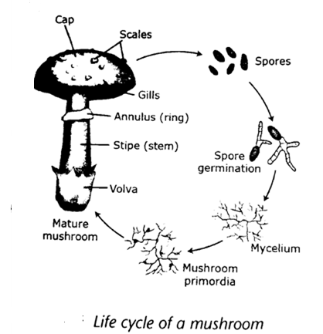
- The cap produces spores which upon failing on a favourable environments, will germinate to from mycelium.
- The mycelium forms secondary mycelium through the fusion of two sexually but compatible mycelium
- Secondary mycelium form the fruiting body (mushroom)
PARTS OF A MUSHROOM

Parts of a mushroom
- Mycelium
- Underground part of the mushroom. It has the hyphae (very tiny filaments often white in colour). It can live for hundreds of years if food is available
- Function: they absorb organic matter and water from the soil for the growth of mushroom
- Fruiting body (sporosphere)
- Part above the ground. It can only live for few days. It has the following parts
- Stalk(stalk/stipe): it supports the cap and transport water to the cap
- Cap: it protects the gills of the mushroom
- Gills: located under the cap. It produces fertile spores
- Spores: they are tiny seeds. Form the reproductive part of the mushroom
- Volva: it is the remains of membrane that covered the immature mushroom. It ruptures as the stem grows.
- Ring: it is the membrane that covers the ruptured gills as the cap grows.it is located under the cap and circles the stem.
- Scales: these are rough patches of tissues on the surface of the cap. These are remains of the veil.
- Veil: this is a thin piece tissue that connects the cap to the stem in young mushroom
Cultivated species of mushroom in Malawi
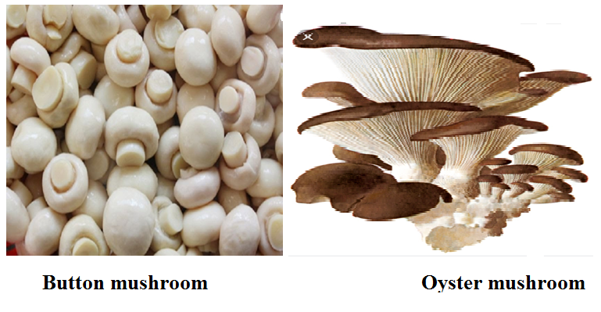
- Oysters species
- Light tan to cream in colour
- It has a large fan-like cap and short stem
- It is delicious flavour and can be eaten raw in salad or cooked. It is also used as an ingredient in soup
- Button species
- It is hard and dome shaped
- The colour varies from white to light brown
- It has nice flavour and can be used in salads and soup
- It can be canned or driers.
- Shiitake species
- It is broad and has an umbrella shaped cap
- Its colour ranges from tan to dark brown
- It tastes like steak when cooked
- Button mushroom
- Two varieties are recommended.
- TNS 1
- Requires a cropping temperature of$16℃-20℃$.
- It is white in colour
- Has potential yield of 15kg per square metre.
- TNS 2
- Requires a cropping temperature of$18℃-22℃$. It is bigger than TNS 1
- It is white in colour and scaly with a potential yield of 15kg square metre.
- The temperatures are prevalent between March and July in most parts of the country. Therefore mushroom can best be grow in these months
Differences between oyster mushroom and button
- Oyster mushroom are easier to grow than button
- Button have better taste than oysters
- Oyster are less capital intensive than button
- Oyster have shorter shelf life than button
- Oyster fetch lower prices on the market than button
- Oyster are good for beginning mushroom growers because
- easier to grow
- less capital intensive
- Button mushroom require special compost and fertiliser and hence farmers find it difficult and expensive to produce.
Importance of mushroom production
- They are source of food, providing proteins, vitamins and minerals which are vital for good health.
- They are also good source of income to growers
- They are source of foreign exchange
- Mushroom production can assist in diversification and provides a better way of utilising crop, forestry and animal wastes.
- After cultivation, the substrate can be used as manure
Husbandry practices for mushroom production
- Selection of species
- Selection of site
- Construction of incubation and production sheds
- Substrate preparation
- Spawn source (buying and preparation)
- Substrate treatment
- Mushroom seeding
- Mushroom fruiting management
- Harvesting
- Selection of species
Factors to consider when selecting species for mushroom
- Availability of waste material used as growth medium
- Presence of suitable environmental conditions
- Availability of expertise in growing mushroom
- Availability of capital
- Market demand for species you want to grow. Always checks the taste and preference of consumers in your area. You should aim at satisfying the need of consumers
- Site selection
- It should be away from livestock kraal, rubbish pits and latrines to avoid attracting flies
- It should be near a market in order to sell mushrooms fast since they are highly perishable
- It should be near a dense forest to provide an ideal condition for mushroom growth because humidity and availability of woods
- It must be free from pests and diseases otherwise mushroom can be destroyed
- Climate conditions. A warm rainy and humid environment. temperature range of 12-24
- Availability of transport for both produce and substrate so that they rich are of need faster.
- Construction of incubation and production house
- Cultivated mushroom are grown in a house
Qualities of a good mushroom house
- The house should include a dark for incubation and light production room for fruiting
- The house should provide a suitable humidity, temperature, ventilation and moisture
- Ensure ventilation by use ventilators and doors which face in face in the direction of wind and shelves to prevent carbon dioxide build up in the house
- Use of insulation materials (plastic sheet and grass thatch) to prevent temperature fluctuation in the house and increase efficiency of air conditioning.
- Should be solid and sloping for easy cleaning and to allow water to drain
- Sand should be placed on the floor since it absorbs water
Positioning of the house
- Should face the windward side and should be shielded from the sun
- It should be well ventilated
Materials for constructing incubation
- Poles, heavy gauge, plastic sheet, grass, bamboos, timber, nails, wires or plastic gauze.
Procedure for constructing incubation and production sheds for mushroom
- Clear the site
- Measure site 5m by 3m
- Digging of the holes and fixing the poles into them
- Construct the walls of the house 2m high using bamboos, strings or twigs
- Construct shelves inside the sheds 0.5m to 1.0m in width. The length depends on the size of the sheds
- Thatch the walls with grass
- Cover the remaining 0.5m of the walls from the roof with a clear plastic sheet
- substrate preparation
- substrate is any material which is organic in nature on which mushroom grows
Materials for substrate preparation
- maize Stover, rice hush, maize cobs, cotton wastes, saw dust, banana leaves
Ingredients (supplements) which can be added to the substrate
- molasses, fertiliser, like single super-phosphate, lime, chicken manure, soya beans powder or cotton seed cake
PROCEDURE FOR PREPARING MUSHROOM SUBSTRATE
- steps for preparing maize Stover (maize stalk, husks and cobs) as substrate for mushroom
- chop the materials into smaller length (shredding process) for easy filling into sucks
- soak them for few hours so as to soften them up
- drain the water (blending process)
- treat the substrate to kill the germs
- steps for preparing cotton wastes as a substrate for mushroom
- soak the cotton wastes for few minutes in water mixed with detergents as a softener and disinfectant
- squeeze water out of the cotton wastes
- loosen the cotton
- treat the substrate
- steps for preparing saw dust from hard wood as a substrate for mushroom
- moisten the saw e dusts
- add supplements’
- incubate it overnight
- add supplements
- treat the substrate
- steps for preparing rice bran as a substrate for mushroom
- soak the rice bran in powered soap solution like OMO for ten minutes
- rinse the substrate to clean water until all the soap bubbles have disappeared
- treat the substrate
- Spawn source
- Buying or preparation of spawn
- Spawn can be bought from the following places in Malawi
- Lilongwe sit of agriculture and natural resources
- Natural resources college
- Biology department at chancellor college
- Vumbwe research station
- Spawn preparation involves three stages
- Culture medium preparation
- Materials used as culture medium preparation
- Potato Dextrose Agar Substrate
- Malt extract agar
- Tissue culture collection and preparation
- Spawn colonisation
Stage 1: culture medium preparation
- Culture medium is nutrients agar substrate on which mushroom fungi will be grown
Martials used for culture medium preparation
- There two types
- Malt extract agar
- Potato dextrose agar or PDA

Process of preparation of nutrient agar substrate
- Wash and weigh 200g of European potatoes or ordinary potatoes and cut them into small pieces.
- Boil for 15 to 20 minutes in 1L of water until they are soft. Drain and save the water.
- Make water back up to 1 L with fresh water;
- add 20gm dextrose and 18-20 gm agar.
- Heat until the agar dissolves
- Sterilise the agar in autoclave for$121℃$,for 15 minutes.
- Culture medium is poured into test tubes ($1/4$ full) or Petri dishes ($1/2$ full)
- Let the medium cool on the laminar airflow table
Process for preparation of Malt extract agar
- Add 20g of the extract to 1L of water and 18-20g of agar
- Heat until the agar is dissolved
- Put into bottles
- Plug and sterilise
Note that: malt extract agar can be available in both syrup or powder and they are normally found with amateur beer makers.
Note: laminar airflow table is an enclosed bench designed to prevent contamination of biological samples. The device separates air flowing through it into layers.
Stage 2: tissue culture collection and preparation
Materials needed
Fresh mushroom, alcohol (spirit or ethanol), razor, blade and forceps, cotton wool, bottles
Procedure
- Wash hands in alcohol to make them free from germs
- Break the mushroom with clean hands to expose the gills
- Remove the tissues between the gills and the upper part of the mushroom using forceps
- Place the tissue in sterilised test tube or petri dishes using the forceps
- Close the bottles near a flame with cotton wool
- Place the petri dishes and the bottles in an incubator or at room temperature
Stage 3: spawning (spawn colonisation)
Materials needed: sorghum, millet, and whole rice
Procedure
- Soak all the materials for preparing spawn in water for a day
- Remove the water
- Put the materials in sterilised bottles
- Sterilise the materials
- Let the contents cool
- Mix(inoculate) the tissue culture with the sterilised materials
- Put the inoculated bottles into an incubator for 15 days. The mycelium would have colonised the materials by that time
- Substrate treatment: the substrate should undergo sterilisation process to kill germs
Sterilisation
- Sterilisation by steam

- Home-made sterilizer
- This is made from an open drum with a perforated platform (with holes)
Procedure
- Put some stones in the drum to create a platform
- Pout 10 litres of water into the drum
- Fill the drum with substrate
- Cover the top with a plastic sheet and make a hole in the middle of the plastic as a safety valve
- Tighten the drum with a sisal string or linya
- Heat the drum until steam reach the top
- Leave the substrate to cool
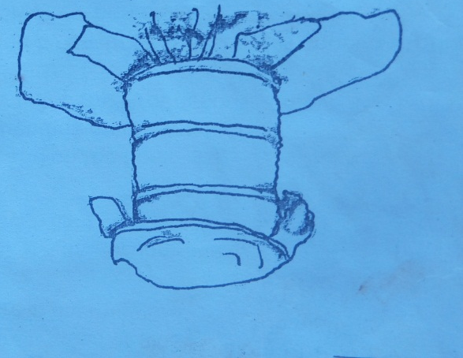

- Use of autoclave
- Pack the substrate in the wire mesh baskets
- Put the basket into the autoclave machine and sterilise the substrate for 1 hour
- Remove the baskets from the machine and empty the content on the plastic sheet and let it cool
- Note that: substrate should be properly treated to avoid infection since mushrooms are sensitive to poor hygiene
- Sterilisation by immersion in hot water
- Soak the chopped materials in hot water for 3 hours to soften them up
- Drain the water
- Chemical sterilisation by soaking in water
- Mushroom seeding: seed for mushroom is called spawn
Procedure for seeding mushroom
- Wash hands thoroughly
- Pack the substrate into plastic bags
- Broadcast three quarters of the required amount of spawn in the substrate
- Mix the spawn with the substrate through
- Broadcast the remaining spawn on the top layer of the substrate
- Tie the mouth of the bag with a string
- Incubate the spawn bags in the dark rooms or covet with a plastic sheet until bags are fully colonised (if colonisation is successful the whole substrate will turn white) colonisation take place after 21 days depending on the temperature.
- Transfer them into the fruiting house where there is enough light for mushroom to start forming
- Tie the bags on the racks and make few slits on the bags using a razor blade or a sharp knife.
- Mushroom fruiting management
- Mushroom fruiting is the stage where mushrooms emerge from mycelium. The activities involved are
- Monitoring the spawn running
- Monitor the spawn as it develops until running on the running on the substrate
- A white colour indicates the growth of mycelium. If no growth occurs, it implies that the substrate is too wet/too dry or the temperature was too low.
- Casing should be done when mushroom have begun to emerge thus 14 days after the substrate is fully colonised with mycelium.
- Casing is the process of adding moist soil to the spawn.
- Clay loam taken from sub soil and should be low in organic matter content and PH between 7.0 and 7.5.
- temperature of moist soil should be between $16℃ and 22℃$
- It is put on top of compost for about 3 to 4cm and bout 30kg of soil is required per square metre.
Importance of casing
- promotes and stimulates formation of fruiting bodies
- Retains the needed moisture for mushroom growth
- Monitoring the colour change
- The normal colour of mycelium is white. It is important to monitor colour change to know whether there is growth or not. If the substrate is green or pink in colour or partly showing signs of white growth it means the temperature of the fruiting house is too high
- Hanging in the production sheds
- When the bugs are fully colonised hung them in the production sheds
- Importance: it ensures that all bags receive enough light
- Watering
- It is done by sprinkling water on the bags, wall and on the floor
- It is done twice or three times a day depending n the weather.
- Importance: to maintain freshness and humidity in the mushroom house (above 80%) this will enhance fruit development
- Note that: freshness in the house can also be maintained by ensuring that there is enough ventilation in the house by routine opening of vents to avoid accumulation of carbon dioxide
- Accumulation of carbon dioxide will lead to development moulds and bacterial
Harvesting mushrooms
FACTORS TO CONSIDER WHEN HARVESTING MUSHROOM
- Maturity of the mushroom
- Ready for harvesting when button appear which fetch high price on the market.
- Mushroom can also be harvested when the caps appear (when the veils have opened).
- Can also be harvested when the flats appear and at this time the veils open up and the caps are flats and gills are fully opened.
- Market requirement
- Most consumers prefer button to the rest because mushroom have a good taste at this stage.so most farmers harvest mushrooms before they start to open. Flats have less demand on the market.
- Plucking
- Mushrooms are ready for harvesting after 14 to 20 days after casing and they come in weekly flushes. Harvest mushroom at the right time to ensure continuous formation of the new ones. Leaving mushrooms for a longer period without harvesting will only increase the size of mushroom not the number. The right stage for harvesting depends on one’s own market.
- Marketing
- Mushrooms ready for markets are divided into three grades depending on the size and degree of maturity. These are
- Buttons: these are small enclosed mushroom. They fetch high prices on the market because of good taste
- Caps: these are older buttons. These are mushrooms whose veils have opened but still have rounded caps. They have medium size value
- Flats: these are the mushrooms whose veils have fully opened, the caps are flats and the gills are fully exposed. They fetch low prices at the market.
PROCEDURE FOR HARVESTING MUSHROOM
- Hold the cap
- Twist the mushroom
- Pull it together with the roots
- Cut off the root
- The hole left behind should be filled with fresh casing soil
- Watering of beds should be done soon after harvest
Essay question 2019
Describe any five factors to consider when harvesting mushroom
- Market- when harvesting mushroom there must be a market already available
- Prices-mushroom should be harvested when demand is high
- Maturity of mushroom-it is important for the farmer to harvest the mushroom when it has fully matured
- Threat to pests, diseases and theft; when a farmer knows that the mushroom is at risk for being stolen or damage they have the mushroom
- Transport –farmers should consider securing transport when harvesting mushrooms to ensure that they reach customers quickly
- Labour-whenever mushroom is to be harvested it is important to have enough personnel so that the mushrooms should be harvested quickly
PEST AND DISEASES OF MUSHROOMS
- Main pests of mushrooms include: flies, rats, snails and mites
- Phorid and scarid flies
- Are attracted by the odour of the mycelium
- The flies do not harm the mushrooms as such but they lay their eggs on the mycelium
- It is the larvae (maggots) which eat and damage the stems, gills and mushroom themselves.
Control
Flies can be controlled by
- Keeping the fruiting rooms clean
- Removing the old and contaminated bags regularly
- Setting up fly light traps
- Nematodes are known to prey on the mushroom fly larvae
- Rats
- Are usually a problem if the surroundings are dirty
- They damage the substrate bags
Control
- Setting traps
- Keeping the surrounding clean
- Keeping cats
- Snails
- Eat mushrooms at night
Control
- By hand picking and killing them
- Bats and traps are also used
- Use of salts
- mites
- are tiny spiders
- they eat mycelium or the actual mushrooms
- they are also carriers of green moulds caused by Trichoderma and other fungal diseases
Control
- by spraying quicklime
- spraying malathion
- beetles
Damage caused
- eat the fruits
- make holes in the gills and hide inside
Control
- hand picking and destroying them
Diseases of mushrooms
Examples of other fungal diseases
disease | Diseases causing organism | Damage caused | control
Dry bubble | Verticilium fungicola | - Distortion and spotting  - Mushroom stems with tilted cap  - Mushrooms are deformed | - Proper hygiene and sanitation  - Sterilisation of substrate
Wet bubble | Mycogone pernicious | Mushroom are deformed | - Use of bacterial and actinomycetes as biological measures  - Steaming at 54.4$℃$. for 15 minutes  - Spray benomly
Cob web | Cladobotyum dendroides | Soft rot or decay of fruiting body | - Sterilisation  - Sanitation and hygiene (regular cleaning and removing dead mushrooms)  - Spraying fungicides such as chlorinated lime
Trichoderma green moulds (most common disease ) happen when the substrate is contaminated  It is an air borne disease and can also be transmitted by flies and mites | fungus | Green moulds appear as spots on the dead mushroom and substrate | - Remove contaminated substrate  - Splaying chemicals  - Observe hygiene

UNIT 12 LIVESTOCK FEEDS AND FEEDING
Classes of livestock feeds
- Farmers keep different types of animals on their farms. These animals have different requirements due to the differences in their digestive systems. It is against this background that animals’ feeds are grouped into different classes.
- A feed Feeds: animals’ food
- Feed: is a mixture of several feedstuffs that will supply the required nutrients to animals
- Feedstuff: is food material containing one or more nutrients.
Classification of feedstuff
- They ae classified into
- Roughage
- Concentrate
- Roughage
- These are feeds from plant matters hence they have high fibre content.
- The form the bulk feed for ruminant because they are able to digest feed cellulose (feed with high fibre contents)
Characteristic s of roughages
- Have high fibre contents
- High moisture content
- Low protein content
- Low digestibility due to higher fibre content
Types of roughages
- Dry roughage
- Have high fibers contents
- Low energy value
- Contain very little moisture (less that20%)
- Examples: hay, maize stovers, groundnuts haulm
- Succulent or green roughages
- They are so bulky with high mass per unit
- High moisture content (20-50%)
- Low dry matter content
- Contain carotene rich in vitamin A
Examples green roughages
- Fresh grass such as star grass, kikuyu grass, elephant grass, giant star grass, silage, bananas stems.
- Legumes pasture which are rich in proteins, for example; Lucerne, Leucaemia, desmodium spp, Glycine spp and the like.
- Browsing trees and shrubs which are mainly found in semi-arid areas e.g. acacia.
- Vegetables such as cabbages and kale
- Sweet potato vines and turnips
- Concentrates
- Have high carbohydrates and protein contents
- Low in crude fibre content less than 20%
- Low crude fibre contents
- The main diet of non-ruminant because they cannot digest cellulose
Types of concentrates
- Energy(carbohydrates) concentrates
- Protein concentrates
- Energy concentrate
- These are rich in energy and examples are follows
- Cereals grains. maize, wheat, sorghum
- Process cereals: maize bran. Wheat bran, barley bran, molasses
- Proteins concentrates
- Protein concentrate of animal origin: e.g. cotton seedcake, sunflower, legumes (g/nuts, beans, peas, soya
- Protein concentrate of animal origin: e.g. fish meal, milk, wheat meal, blood meal, liver meal, liver meal, bone meal.
- Additives should be given to animals apart from roughages and concentrates and these include vitamin and mineral supplements
- Feed nutrients
- Feedstuff can contain one or more nutrients. These feed nutrients include; water,
- carbohrates,fats and oils, proteins, vitamins and mineral
Functions of nutrients in livestock feeds
Nutrient | function | source

water | - Essential for body cells and activities  - It makes the cells turgid thus maintains the shape of the body  - It lubricates body joints  - It helps in the transportation of body fluids  - It helps in regulating body temperature | Drinking water, succulents, milk
Carbohydrates (starches and simple sugars) | - Provide energy  - Excess are stored in form of fats | Cereals (such as maize, sorghum, millet, madeya), potato, vines, grass, roots tubers (such as cassava)
Fats and oils | - Provide energy (twice as much as carbohydrates)  - Essential component of body cells  - Excess fats stored in body acts as insulating layer in vitamin’s body and prevents loss of heat  - They are carrier of fat soluble vitamins A, D and K | Oil seeds such as ground nuts and cotton seed, soya beans, milk, eggs, meat, fish meal and bone meal
Protein (made up of amino acids) | - Body building and repair worn out tissues  - Components of enzymes, hormones and antibodies  - Excess are converted into energy | - Grain legumes  - Meat, liver, milk  - Bone and fish meal
Minerals(caicium and phosphorus) | - Bone formation  - Calcium for egg shell formation  - Milk formation | - Milk,  - Meat  - Bone meal  - lime
iron | - part of haemoglobin  - prevents anaemia | - Egg yolk
magnesium | - for healthy bones and teeth  - helps to metabolise carbohydrates | - Milk, cereal grains
iodine | - growth f thyroid grand, which produce thyroxin  - prevents goitre | - Iodised salts
Copper and cobalt | - form part of haemoglobin and enzymes (cobalt form part of vitamin B12)  - improves appetite in ruminant s  - prevents anaemia  - maintain blood pressure  - essential for bile formation | - Salts containing copper and cobalt
Sodium | - maintain blood pressure  - essential for bile formation | - Common salts and rock salts
manganese | - helps in bone formation and enzymatic reactions  - essential for metabolism of proteins and carbohydrates | - Most feeds
chlorine | - part of gastric juice  - aids digestion | - common salts and rock salts
potassium | - helps in functioning of muscles and the heart  - activates enzymes | - Potassium chloride, grass
zinc | - helps in enzymatic reactions | Most feeds
Vitamin A (fat soluble) | - eye sight and growth  - ‘prevention of diseases | - Milk, fresh grass, yellow maize, fish, cold liver oil
Vitamin B (water soluble) | - Carbohydrates, proteins  Fats | Green vegetables, groundnults meal, cereals, fish meal, ruminants sysnthese vitamin B through the micro-organisms that are found in rumen
Vitamin C (water soluble) | - Diseases resistance | Green leafy vegetables, fruits
Vitamin D (fat soluble) | - Bone formation  - Prevents rickets | Sunlight, fish liver oil, yeast, green grass, hay
Vitamin E (fat soluble) | - Proper functioning o reproductive system  - Prevents sterility in animals |  | Grains, cereal grains, groundnuts oils, green vegetables, green grass and other green folders, soya beans, grass
Vitamin K (fat soluble) | - Blood clotting  - Prevents bleeding  - Helps transporting nutrients |  | All feeds, especially succulent roughages or leafy vegetables
Feed ration
- A ration: is the amount of feed given to the animals everyday
- For animals to grow well they need a balanced ration
- A balanced ration: is the amount of feed that contains all the nutrients and in the right proportions.
Types of ration
- Maintenance ration
- Amount of feed that the animal needs per day to maintain its body processes without gaining or losing body weight.
Examples of body processes
- Respiration
- Movement
- Blood circulation
- Body temperature
- It is important for young animals or animals in gestation (pregnancy period)
- Production ration
- Amount of feed given to animals over and above maintenance ration
- Essential for animals to produce eggs, milk and meat
- No one feed has all the necessary nutrients to keep animals healthy. choice of feed stuff to use depends on
- Its availability
- The cost of the feedstuff
- Its nutritional composition
- The physical or processing nature of the feedstuff such as colour, smell, particle size
- Commercial livestock are very expensive however the additives are well balanced
Advantage of home-made feed
- Home-made feed is cheaper
Disadvantages of home-made feeds
- Mixing of the various feedstuff may not be thorough
- Seasonality of the grains. They may not be available at the time they are required.
- Farmers may lack technical know-how on feed value formulation
Methods of ration formulation
- There are many ways of ration formulation. But the commonly used method is called the Pearson’s square methods.
Pearson square
In order to use this method, there is need to know the following
- Animals’ feed requirement
- Nutrient composition of the ingredients and this target only proteins
- Can only be used for two feed stuff.
- When mixing only two feedstuff

Examples
Formulate a pig ration containing 20% protein using maize meal containing 7% protein and fish meal containing 62% protein. Calculate the mount in kilograms of each feedstuff required to prepare 100kg of the feed.
Procedure
- Draw a square
- Place the desired protein percentages in the ration in the middle of the square
- Draw diagonals of the square
- Place the percentage of each stuff at the left corners of the square
- Subtract the figures diagonally across the square. Remember to subtract the smaller number from the larger one.
- Disregard the negatives signs
- Place the number obtained on the right corners, giving the required parts of each feedstuff to be used in the mixture.
- Add up the parts to obtain at the base what will be used to calculate the amount of each feedstuff to be used in preparation.
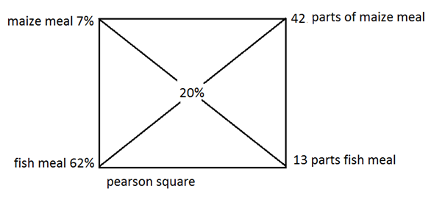
$$total parts=13+42$$
$$=55 ,$$
$$maize meal=\frac{42}{55}×100kg$$
$$=76.4kg,$$
$$fish meal=\frac{13}{55}×100kg,$$
$$=23.6kg$$
- From the calculations above, when 42 parts of maize meal are mixed with 13 parts of fish meal, the results will be 20% protein ration.

How to prepare a ration using three ingredients using a Pearson square
Procedure
- steps are the same with those followed when formulating a two ingredients feed
- the two energy sources or protein sources are placed at the left corners of the square and there is need to find average of the two
Example
Formulate a 30% proteins feed using soya bean which contains proteins and wheat and maize bran as source of energy sources for feed containing 15% and 10% respectively.
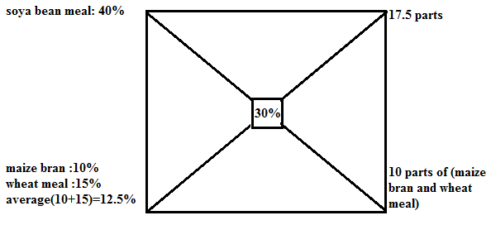$total parts:10+17.5=27.5parts$
$$soya bean meal=\frac{17.5}{27.5}×100=63.6\%$$
$$soya bean meal=\frac{10}{27.5}×100=36.4\%$$
- since there are two ingredients contributing to 36.4 then for
- wheat meal, it will be: $\frac{36.4}{2}=18.2\%$
- maize bran, it will be the same: : $18.2$%
Factors to consider when feeding livestock
- The type of animal: ruminants can digest roughages while non-ruminant cannot. Exotic breed require good quality feeds produce high quality products.
- The age and body size of the animal: young animals require less feed than larger animals and some animals will initially only depend on milk until they are introduced to solid feeds
- Physiological condition of the animal. Animals should not be allowed to starve and feed should not be wasted because it is expensive.
- Purpose for which the animal is kept or level of production. Draught animals require high energy feeds and animals kept for milk, meat and eggs require more concentrates.
- The quality of feed; the feed should be easy to ingest and digest
- Palatability: feed should be appetizing to animals. This is due to taste and smell. Animals like appetizing feed.
- Digestibility: the feed should be easy to digest and this depends on the type of the animal.
- The amount of feed and its texture: this will depend on quality and type of the feeds. The coarseness and finest is an important aspect especially for chickens.
- Cost of the feed. Feed should be given to animals which are in production and feed should not be wasted as it is expensive. This also determines the number of animals the farmer is able to keep

UNIT 13 SHEEP AND GOAT PRODUCTION
- The sheep population is, however, low because sheep production is constrained by lack of improved breeding stock, poor husbandry practices parasites and diseases. Therefore the national has to increase the numbers of sheep and productivity of indigenous sheep by practising improved standards of management.
Listing breeds of sheep and goats
Sheep | Origin | Use | Goats |  | Origin | Use
Local Sheep | Malawi | Meat | Local goat |  | Malawi | Meat
Dorper | Persia | Mutton | Boer |  | South Africa | Meat
Hampshire | England | Mutton | Anglo-Nubian |  | North east Africa | Meat
Merino | North coast of Africa | Wool | Saanen |  | Switzerland | Milk
Karakul | USSR, Iran, Iraq | Skin | Toggenburg |  | Asia | Meat
Black Head | Persia | Mutton | Angora |  | Britain | Mohair
Ramney Marsh | Romney in England | Wool | Alpine |  | India | Meat
Corriedale | New Zealand | Dual | Jamnapari |  | East Africa | meat
 |  |  |  | Small African goat | East Africa | meat

- Criteria used for selecting breed of sheep
- adaptation to the climatic and local environmental
- The breed of sheep and selected should be suited to the climatic and local conditions of the area.
- The indigenous sheep are suited to the hot, dry condition of the country.
- The sheep are hardy and adaptable to conditions of low inputs. Local can be improved through cross-breeding and improved management.
- The karakul is adapted to desert conditions, the merino thrives well in dry conditions and black persist is hardy
- Hampshire has been used for cross breeding in Malawi, it can survive on poor pasture, it is heavy breed and good for wool production
- The indigenous sheep breeds have more resistance to parasites than the exotic sheep, but drenching is very important part of sheep management
- Availability of feed. Sheep are managed best when they are kept in well fenced paddocks
- Use
- Select a breed that will give you the highest production of mutton, wool or skin
- Local Malawian sheep produces reasonable amount of mutton, weighing up to 30kg but can be crossed with exotic breed to improve mutton, wool and skin production.
- The black Persian sheep is good for mutton, can weigh up to 50kg but its fat distribution is uneven but can cross breed with Dorset Ram to improve this breed.
- Merino sheep are famous for wool production
- Karakul sheep are good for skin or pelt production.
Mutton sheep have the following characteristics
- Good mothering ability of ewes
- Should be fast growing
- Should have large body weight (size)
- High quality mutton produced
- They are blocky in shape
- Have short legs
- Selecting appropriate breeds of goats
- The purpose for which they are kept, meat, milk or mohair.
Goats kept for meat should be
- Grow fast and mature early
- Be from nannies with good mothering abilities
- Have a good body shape
- Milk goats should have large well-developed udders
- Suitable to local and economic environment
- The Malawian goats are hardy and disease resistant. It is good scavenger; however its genetic potential is limited and this can be cross-breed with exotic breeds to improve meat and milk production.
- Personal preference
- Most Malawians consider local goat meat to be tender and tasty but there is no evidence to prove this claim
The age at puberty for sheep and goats
- Puberty: is the stage in the life of animals when it is sexually mature to start reproducing.
- Male starts producing male gametes known as sperms
- While female animals grafian follicles matures and start releasing female games called the ova (eggs)
Table below shows puberty age for sheep and goats
Animal | Age(months)
Sheep | 15-18
goats | 18
Terms used in sheep and goats production
- Ewe: a mature female sheep which has had more than one lamb
- Ram or tup: a mature male sheep
- Wether: a castrated male sheep
- Hogget: a young female sheep
- Lambs: these are very young sheep
- Billy/bucks: a mature male goat
- Nanny/doe: a mature female goats which has and more than one kid
- Kid : a young goat
- Oestrus cycle: the recurring period of sexual receptivity in female mammals.
- Also known as heat period
- Heat period first occurs when the sheep is around six to ten months
- The oestrus cycle is between fifteen and nineteen days and last for 18-24 hours.
- Flushing: the practice of giving concentrates to sheep two week before mating to improve heath and fertility.
- In goats: oestrus cycle is 18 to 21 days and heat period last for about one to days
- The best time to mate animals is five month before the rains starts so that animals will bear young kids or lambs when there is plenty of food.
- Kidding: the process of giving birth in goats while
- Lambing the process of giving birth in sheep and
The following are signs heat period in goats
- The nanny frequently wags or twitches of her tail
- Shows signs excitement
- Sometimes mounts other nannies
- Vulva become red and thick
- Mucus discharge from the vulva
Gestation period
- Refers to period between fertilization and kidding or lambing.
- Its 5 months or 150 days in both goats and sheep
- During this period the animals should be well looked after and should be regularly be drenched or dosed against internal parasites and vaccinated against diseases
- They should be given concentrates one to two months before lambing or kidding and this is called steaming up.
Characteristics of good sheep house
- Spacious
- Strongly built because sheep are prone to predators
- Well ventilated to prevent spread of diseases
- Well lit
- Dry and easy to clean
- Easy and cheap to construct
Characteristics of good goat house
- It is sited on a high ground
- It is cheap to construct
- It is strongly built
- It is roomy-with a floor space of about ${1.0m}^{2}$
- It is well lit
- It is well ventilated , drought-free and dry
- It has hard floor made of concrete or hardened/rammed earth or clay
- It has well thatched roof
- It is well drained and easy to clean
- Kids and nannies are usually housed in separate pens and nannies are housed together with one or two Billies.
Construction of sheep and goats house
Materials required
- Poles and twigs for rafters
- Ropes
- Sisal, linya and string
- Pangas and axes
- Nails
- Bamboos
- Thatch grass
- Bricks and stones
Procedure for constructing goats and sheep house
- Assemble the materials required
- Lay out the site using tape measures, mallet, pegs and strings
- Clear the area of any bush or plants and digs the foundation
- Us the poles to stack out the corners of the house
- Lay stones in foundation until ground level
- Built up the wall up to about 60cm then use bamboo to raise the rest of the wall up to the rafters
- Use poles and bamboo to construct the rafters on the roof
- Cover the roof with grass thatch and use sisal or linya to tie the grass to the roof poles.
Feeding behaviour of goats and sheep
- Sheep and goats are ruminants that depend mostly on pasture or grass.
- Sheep are more grazers than browser.
- While goats are both grazers and browsers
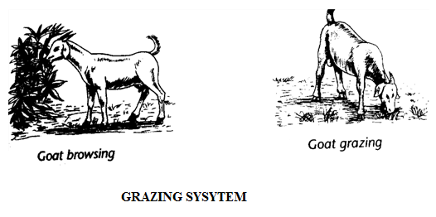
Different between grazing and browsing
- In browsing, the animal eats any parts of the plant. Goats will therefore eat plant leaves, stems and even roots. They eat barks of stem. Goats can end up destroying trees to point of death causing deforestation. This is why they are called browsers.
- In grazing, animal will eat grass and or herbs. Where possible, grazing animals can eat selectively, eating only the most palatable plant species. In grazing correct stocking rate prevents pasture destruction. Browsers can destroy trees when grass and edible herbs are readily available.
Docking
- The process of cutting tail of an animal
- In lambs docking is when it is four or five weeks old
- The tails are cut about 5cm from the body
Reasons for docking
- It prevents dirt and dung from collecting under the tail, which could otherwise be a source of infection.
- It helps in parasites control(for example, it is easier to remove external parasites such as ticks from the anal area)
- It helps improve the quality of the carcass in fat tailed sheep
- It helps the animal to mate easily
Identifying suitable feeds for sheep and goats
- Forage plants
- Grass
- Legumes e.g. lucerine
- Shrubs and trees whose leaves are browsed.
- Roots
- Cassava
- Sweet potatoes
- Yams
- Roughages
- Mature pastures e.g. dry forage
- Residues from crops e.g. straws and haulms
- Concentrates
- Protein concentrates of plant origin e.g. groundnuts, cotton seed, sesame, soya beans, sunflower, and coconut.
- Protein concentrates of animal origin are by-products from processing of carcases, fish or milk.
Sheep and goats feed are selected for the following reasons
- They provide a balanced ration
- They are locally available since they are made from local crop residues
- Some can be bought cheaply
- Some can be grown on the farm
- They are free from toxic substances
- They can be dried and stored for use during the dry season
- They contain allots of nutrients
System for managing goats and sheep’s
- Extensive system
- Animals are kept freely during the day to graze and browse. Sometime they are supervised by herders.
- Tethering
- Animals are tied to a tree during the day.
Types of tethering
- Picket: animals are tied by collar and chain to stake driven into ground
- Running tethering: animals are chained to metallic pipe fixed on the ground horizontally.
- Semi-intensive
- Animals are housed at night and fenced in paddocks at least 2 hectares during day. Clean water should be provided to the goats.
- Intensive system
- Also known as zero grazing or stall feeding or cut and carries. Under this system goats re kept in the house and feed brought to them.

Diseases of sheep and goats
Diseases: is a physiological or anatomical disorder or abnormality in an animal which can be identified through characteristic symptoms on the anima
Table showing common sheep and goat diseases and their control
diseases | Causative agent | Signs and symptoms | Treatment and or control measures
Nasa-worm | Nasal bot (worm) fly | - Small grey-greening fly with prominent black spots on thorax-fly covered with short light-brown hairs  - Sneezing and thick nasal discharge | - Spray or dip  - Use a fly repellent like Stockholm tar to repel flies off seed
Foot and mouth | virus | - High fever  - Inflammation of tongue, lips, and gums making it difficult to eat  - Lameness  - Profuse and continuous salivation | - Imposition of quarantine  - Vaccination every six months  - Slaughter, burn and bury infected animals  - Disinfect(sterilize) animal’s hooves
Mastitis | bacteria | - Blood clots or pus in milk  - Swollen udder  - Drop in milk yield  - Rise in body temperature | - Practice hygiene during milking  - Treat with antibiotics  - Use disinfectants  - vaccination
brucellosis | bacteria | - abortion in late gestation  - retention of placenta  - yellow, brown, slimy discharge from the vulva may occur | - cull and slaughter infected animals  - disinfect areas contaminated with uterine discharges  - proper disposal of aborted foetus  - use of artificial insemination  - a blood test for all breeding herbs to detect infected animals
pneumonia | bacteria | - severe respiratory problems  - abnormal lung sounds such as bubbling, hissing and gurgling  - animals appears dull and losses appetite | - keep young animals in warm house  - treat early cases of the diseases with antibiotics  - isolate sick animals  - Ensure proper ventilation in the animals’ houses.
Sheep pox | virus | - High fever  - Dark red pimple/lesions  - Some lambs die  - Abundant mucoid nasal discharge
Goats and sheep diseases are categorized into
- Protozoan diseases e.g Anaplasmosis, Conccidiosis, Trypanosomiasis
- Bacteria diseases e.g Brucellosis, Mastitis, Pneumonia
- Viral diseases e.g. Rinderpest, Foot And Mouth Diseases
- Nutritional diseases e.g. Milk Fever, Bloat
Parasites of sheep and goats
- External parasites
parasites | Parts of the body attacked or damaged | Treatment/control
Ticks | - Ears, tail, udder  - Suck blood thereby causing anaemia  - Transmit diseases like heart water and red water | - Dipping animals regularly, fortnightly during dry season and weekly during rainy season  - Spraying called acaricides  - Hand picking  - Fencing restrict movement thereby minimising spread of ticks  - Rotational grazing reduces the build-up of ticks in a pasture  - Burning the infested pasture can kill destroy life cycle of ticks  - Ploughing the land buries ticks deep into the ground
Scaly mites | - Skin  - Cause itching | - Dipping  - spraying
Lice | - skin  - head  - foot  - suck blood | - dipping
Tsetse flies | - found in humid, bushy areas  - they become active during the day  - transmit trypanosomiasis (nagana) in livestock | - spraying  - sterilization of the male tsetse flies by use of chemicals  - clearing bushes in areas infested by tsetse flies  - Trapping of flies by using of special nets treated with appropriate chemicals. The chemicals are usually laced with insect attracting pheromones
- Internal parasites
- Liver fluke
- inhabit bile duct of sheep and goat
Effects of live fluke on goats and sheep
- digestive upset due to blockage of bile duct
- swollen abdomen
- demaciation(loss of body weight)
- anaemia due to destruction of live tissues
- edama in jaws(swelling)
- death due to severe demaciation
Control measures of liver fluke
- routine drenching using drugs
- destroy water snails by treating swampy water with copper sulphate
- fence of heavily infested swampy areas to prevent farm animals from razing in such infested areas
- drain swampy areas within the farm
- Tape worms
- are host-specific
- two common ones which attack livestock are
Signs of tapeworms attack
- attacks by these worms make rough coat on animals
- make digestive disturbances like diarrhoea and occasional constipation
- animals develop pot bellies
- anaemia
- oedema
- presence of egg segments
- proglottides in the faeces
To control tapeworms
- routinely de-worm animals using appropriate drugs
- plough the pasture land to kill the cysts
- proper disposal of human waste e.g. use of latrines
- proper cooking of meat
- rotational grazing
- proper meat inspection
- Round worms
- Usually cylindrical in shape and pink white in colour.
- Exist separately as male and female
- They inhibit the alimentary canal of sheep and goats
Effect of round worm on sheep and goats
- Retarded growth
- Scours
- Anaemia
- Stiff dry coat
- Diarrhoea
- Constipation
- Pot belly
Ways of controlling round worms
- Avoid grazing on muddy ground
- Avoid grazing on wet grass in the morning and when larvae are active
- De-worm animals using appropriate drugs
General ways of controlling parasite and disease in livestock’s
- Vaccination: this is a preventive measure to offer immunity against a particular diseases
- Dipping/spraying: done regularly to kill vector which transmit disease
- Deworming: this is the administration of drugs to live stocks to control internal parasites
- Dosing to treat sick animals because drugs kill disease causing organism e.g bacteria
- Disinfect the house to kill pathogens
- Keeping the house clean to avoids spreading and multiplication of disease causing organisms
- Proper human waste disposal
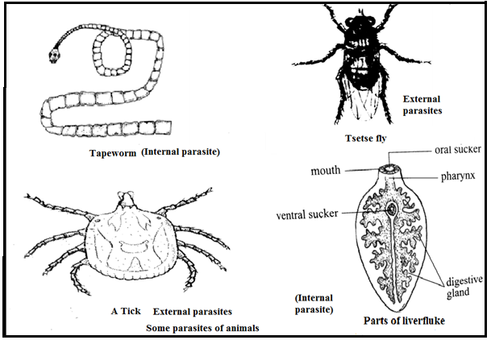

REFERENCE MATERIALS
- Excel and succeed, student book 3
- Arise with agriculture student book 3
- Jhango senior agriculture , student book 3
- East African agriculture, third edition
- Chanco senior in agriculture, question and answers\
- Achievers in agriculture ,book 3
- Strides in agriculture book 3

